**CHAPTER III**

**TECHNICAL BACKGROUND**

This chapter presents the technical considerations in developing the VirtualShrine: An Interactive Museum Website for Casa Real Shrine. The project approach, conceptual framework, Visual Table of Contents (VTOC) of Casa Real Shrine, conceptual system design, security matrix, and deployment diagrams will be discussed.

**Project Methodology**

The quantitative technique was used in the study to collect data from visitors of the Casa Real Shrine of Malolos. The proponents gathered statistics on visitor satisfaction comparing the present museum operations without the website and the museum operations after the website is implemented.

The research and development element of the design involves (1) analyzing the existing museum operations, (2) innovating and developing a system based on the findings, and (3) testing the efficacy of the innovation.

The approach includes a quantitative examination of the program/system, its components, as well as implementation and outcome data. Essentially, the procedure includes conducting comprehensive documentation analysis.

The study used an agile method for research, it is based on based on iterative development, where requirements and solutions evolve through collaboration between self-organizing cross-functional teams. can help develop the features of the Casa Real Virtual Museum.

Agile has become an integral part of software development due to its ability to quickly adapt to changing requirements and customer feedback while still maintaining high-quality, reliable software on time and on budget. Agile promotes an iterative approach which allows teams to benefit from early feedback and rapid prototyping, resulting in a better software product and a faster time to market Gulati & Sharma (2018). Additionally, Agile reduces the risk of project failure by providing visibility into progress and allowing teams to detect and address any issues early on Custers (2019). Agile also encourages collaboration

**Conceptual Framework**

The Conceptual Model of the System Development is represented in Figure 1. This model outlines the main components and activities involved in the development of a system.

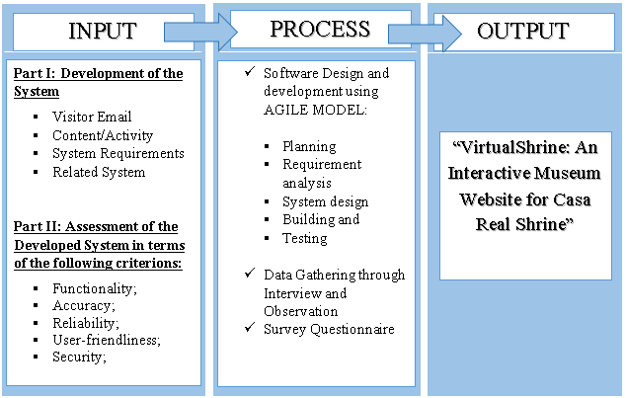

**Figure 1.** **Conceptual Model of the System Development**

The first frame is the input stage wherein it involves the primary data and information of the Casa Real Shrine to develop the system. System Requirements is necessary to have the hardware and software requirements needed to develop the system. Related Systems in books, internet articles, related studies and online research was reviewed.

The second frame is the process stage, wherein this part of the diagram the proponents adopted the System Development Life Cycle (SDLC) is a conceptual model used in project management that describes the stages involved in an information system development project, from a first feasibility study through maintenance of the completed application. SDLC can apply to technical and non-technical systems. In most use cases, a system is an IT (Information Technology) technology such as hardware and software. Project and program managers typically take part in SDLC, along with system and software engineers, development teams and end-users.

In development of the system the proponents used the Agile model. Agile model believes that every project needs to be handled differently and the existing methods need to be tailored to best suit the project requirements. In Agile, the tasks are divided into time boxes (small time frames) to deliver specific features for a release. Iterative approach is taken and working software build is delivered after each iteration. Each build is incremental in terms of features; the final build holds all the features required by the customer.

Agile takes an adaptive approach, rather than relying on exhaustive planning. The focus is on developing features and the team is able to quickly adjust to changing product requirements. Testing is conducted frequently, to reduce the risk of major failures. There are five phases in the Agile Software Development Life Cycle (SDLC): planning, requirements analysis, system design, building, and testing. Agile breaks the product into smaller, incremental builds and is designed to give customers a working software product quickly, while still being able to adapt to the process.

Lastly, for the Output stage, this is the developed system, the VirtualShrine: An Interactive Museum Website for Casa Real Shrine.

 In order to construct the system, each SDLC phase in the Process stage is discussed below.

**Initiation Phase**

In this study, Virtual Shrine focused on the virtualization of the museum for visitors reassuring the safety of the visitors without compromising any content and added content as well. Adding Online Booking Admission to the system added more security for data.

Popular museums had done online 3D virtual tours around 1999, boosting the number of visitors both online, and in person, using the technology now as an advantage to the system. Through an online web-based system the visitors could take the tour anytime and with the Online Booking making it convenient for any visitors. Attentiveness to the system’s performance made sure the plans proceeded as intended in the project for a higher chance of success.

Upon approval of the proposed system, VirtualShrine: An Interactive Museum Website for Casa Real Shrine used the feasibility study and support documentation to begin the planning phase.

**Planning Phase**

The Planning phase is a step before developing the software. This helped the proponents avoid problems during the early stage of developing the project that might have helped them for the future of the software. In creating the VirtualShrine website, the features of the software were important for the developers. That's why creating a plan was a must for the satisfaction of their audience.

Weedmark (2019) added that a good project plan should describe the project, break it down into tasks, estimate resources, develop a schedule, create a communication plan, and write a statement of work. For Casa Real Virtual Museum, the project goal is to reintroduce the importance of museums to new generations. The project tasks should be divided among the members, and resources such as 360 cameras and computers should be estimated. A schedule should be created to ensure the tasks are done on time, and a communication plan and statement of work should be established. Management at Casa Real Shrine should be consulted for requirements.

**Design Phase**

The System Design Phase is a crucial step in the software development process. It involved the conceptualization, specification, and validation of a system. During this phase, the proponents created a detailed design that met the requirements of the client and users. The proponents used Adobe XD as a prototyping software.

Adobe XD is a powerful platform for creating interactive designs, prototypes, and wireframes. It is a great tool for creating high-fidelity designs that accurately represent the intended user experience. Adobe XD also allowed the proponents to easily share the designs with stakeholders, enabling changes and feedback quickly. This helped ensure that the final design met the requirements of all stakeholders.

**Development Phase**

The development phase of the Casa Real Shrine interactive museum website, VirtualShrine, required a significant amount of technical work. This included coding, programming, and database design. The coding involved writing code to create the website's structure and features.

The programming involved creating the logic and backend systems that made the website run smoothly and securely. Finally, the database design involved creating a database to store the data and information associated with the website. In order to ensure that the website was secure and able to handle high traffic, security protocols were implemented and tested. Data encryption, authentication, and authorization were implemented to protect the website from malicious attacks. Additionally, the website was tested for performance and scalability in order to ensure that it could handle high volumes of traffic.

Finally, the website was tested for usability, accessibility, and compatibility with various browsers and devices. This ensured that users could easily use and interact with the website from any device.

**Testing Phase**

The proponents performed beta test during the testing phase to ensure accuracy of code, desired functionality, and website compatibility. The Testing teams gathered and loaded test data into the testing environment. Testers found faults or errors during the process, and procedures were in place to ensure programmers addressed them quickly and documented changes/revisions. This decreased tester downtime and saved programmer time troubleshooting, while maintaining integrity of program documentation. The data collected during the beta testing process was also used to develop new strategies and improve the overall performance of the application.

**Project Evaluation**

The proponents conducted post-implementation evaluations at the end of the project to confirm that project objectives had been met and to evaluate project management actions. The proponents interviewed all people and staff members who had been actively involved in the operational usage of the product or document and addressed any issues that were discovered.

**Implementation Phase**

The implementation phase involved an approved website into production environments. In this stage, the primary tasks included the implementation schedule, training end users, and access to the website.

In addition, Casa Real Shrine had input and verified data, configured, and tested system and security parameters, and conducted post-implementation reviews. Verifying the input data and security parameters for accuracy was an important element of the implementation process. Organizations frequently ran a new system alongside an old system until the new system's quality and reliability were verified. During the verification process, employees documented any programming, procedural, or configuration changes.

**VirtualShrine: An Interactive Museum Website for Casa Real Shrine of Malolos Gantt Chart**

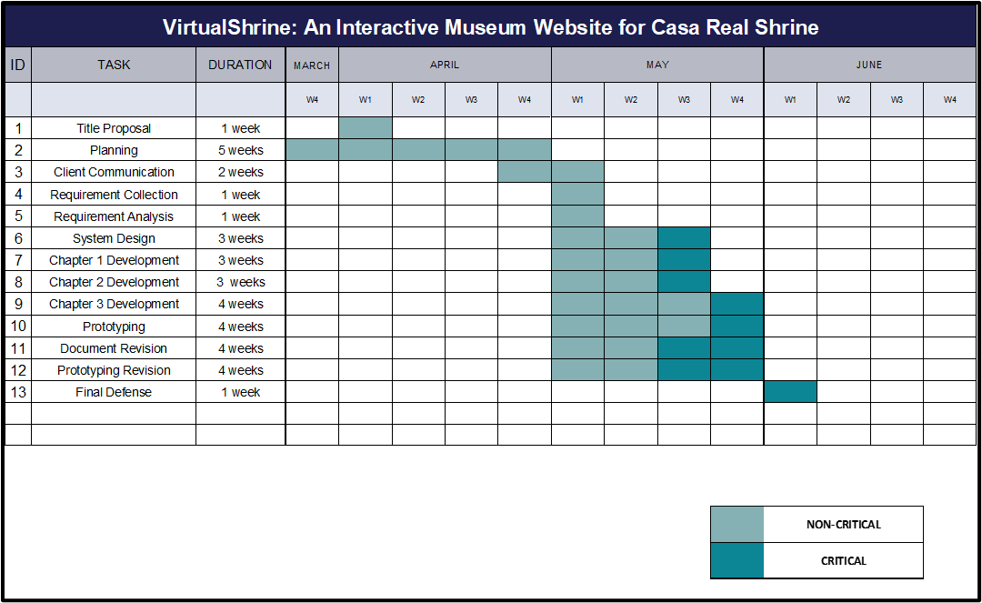The Gantt Chart, as illustrated in Figure 2, displays the schedule that the system's proponents followed during its development. The Gantt Chart was used to track the progress of the system's development.

**Figure 2.** **VirtualShrine: An Interactive Museum Website for Casa Real Shrine of Malolos Gantt Chart**

The timeline for the title proposal was allocated a duration of one week and began in the first week of April. Following this, planning was conducted from the last week of March to the whole month of April, with a duration of five weeks. After planning, two weeks were allocated for client communication from the last week of April to the first week of May. Subsequently, one week was allocated for requirement collection, and another for requirement analysis, both in the first week of May. System Design was then conducted for three weeks, from the first week to the third week of May. Chapter 1 and 2 development was conducted for three weeks, from the first week to the third week of May. Chapter 3 development was conducted over the whole month of May, with a duration of four weeks. Prototyping, document revision, and prototyping revision were conducted over the whole month of May, with a duration of four weeks. Finally, a one-week duration was allocated for the Final Defense, which was conducted in the first month of June.

**Requirements Analysis and Documentation**

The proponents conducted an interview with the museum curator, Mrs. Ma. Antonia T. Jimenez to determine the system requirements and to gain an understanding of the client’s needs and expectations for the project. The proponents also observed the museum operation such as the visitor walk in admission process in order to develop a plan for the online booking process.

**Maintenance Phase**

It entails making changes to software and documentation to support its operational effectiveness throughout the maintenance period. It entails making modifications to improve a system's or website's performance, resolve issues, increase security, and meet user needs. The museum should implement suitable change management standards and procedures to guarantee that alterations do not disrupt operations or harm a system's functionality or security.

**System Specifications**

The web application was developed using HTML, PHP, and JavaScript. The application was built on a MySQL database. The application utilized AJAX for dynamic page loading. Additionally, the application included various front-end libraries such as jQuery and Bootstrap for improved user interfaces and responsiveness. Furthermore, the application included a secure login system and intuitive user experience.

Table 1 details the hardware requirements for developing the system on a computer device. This includes specifications that provide narratives of the parts and functions of the instrument necessary for the system to perform.

**Table 1: Requirements for Web Server**

|  |  |  |
| --- | --- | --- |
| **Hardware Requirement** | **Minimum Requirement** | **Recommended Requirements** |
| Processor | Intel Core i3 or higher processor | Intel Core i5 or higher processor |
| RAM | 4 GB RAM | 8 GB RAM |
| Disk Space | 80GB hard drive | 120GB SSD |

The processor, RAM, and disk space requirements chosen are based on the estimated size of the system museum website and its potential traffic. An Intel i3 or equivalent processor is powerful enough to handle the operations of a smaller website, while an Intel i5 or equivalent processor will provide a more reliable performance for a larger website with more traffic. 4GB of RAM is the minimum required to run a basic website or web application, while 8GB of RAM is recommended for larger websites with more data. 80GB of hard drive space is the minimum required to store the files and data of the system museum website, while a 120GB SSD is recommended for faster loading times and improved performance.

Table 2 Software Requirements. In order to ensure that the system functions properly, it is essential to identify and document the software requirements needed for its design and operation. Table 2 outlines these software requirements.

**Table 2: Software Requirements for the System**

|  |  |  |
| --- | --- | --- |
| **Operating System** | **Minimum Requirement** | **Recommended Requirements** |
| Windows | Windows 7 | Windows 10 |
| Mac OS X | Mac OS X 10.8 or higher | Mac OS X 10.13 or higher |
| iOS | iOS 10.3 or higher | iOS 12.0 or higher |
| Android | Android 5.0 or higher | Android 8.0 or higher |

The minimum operating system requirements are necessary to ensure that the website and its features, such as the 360-degree view, are able to run effectively on these operating systems. The recommended requirements are needed to ensure the best user experience and performance on the website, as newer operating systems are typically more secure and have better performance.

**System Design and Processes**

**Front Office:** The website's front office consists of the following menus: (1) Home. The Home page is the system's default web page. The home page displays a welcome banner for visitors, as well as a "book a tour" and "plan your visit" buttons for visitors' convenience. The homepage also highlights featured exhibitions and information, upcoming events, galleries, and group trips. The homepage also includes a footer with basic information about the museum, contact information, quick links, and a list of social media pages that visitors can like or follow. (2) Plan your visit. This website displays information on the museum's operations, such as the opening time, location, and health and safety guidelines that visitors must follow. This website will assist visitors in preparing for their visit to the museum, this way, they will have a hassle-free visit; (3) Booking Reservation. The visitor can book for reservation for their physical museum visit. Pre-booking is recommended to have a hassle-free visit. The visitor will enter the date and time of reservation, and the number of people who will visit; the system will also ask for the representative visitor information such as name, email that were used for the confirmation, mobile number, address, and the name of company, agency, or school if applicable. At the end of reservation, the visitor will receive an Acknowledgement Receipt on the email they provided with the following details:  (a) Reservation Date and Time; (b) Total number of visitors. (4) Virtual Tour. This page displays the virtual tours such as the permanent and current exhibits, virtual gallery with a 360 view of the 5 galleries available in the museum, and the narrated tours.

**Back Office:** The back office serves as the system administrator and website content manager site where they can view booking lists, approve, or decline bookings, update the website content, post an announcement, and add an assistant admin.

**Head Administrator:** The Head administrator is mainly the museum curators. The Back Office of the head administrator is composed of the following menus: (1) Add user. They will be able to register an assistant administrator. (2) Edit user. able to set their own type of user that will handle the back office. (3) Edit user information. able to modify the assistant admin. (4) Remove user. Has the ability to delete assistant user account in the back office. (5) Reservation. Viewing, approving, and declining of reservation done by the visitor. (6) Update Contents. The head administrator will be able to add, update, and delete the content of the front office.

**Assistant Administrator**: The user of this application is mainly the employee of Casa Real Shrine who handles the booking reservations. (1) Log In enables access to other functions with username and password assigned by the head admin (see security matrix Table 5). (2) Reservation allows viewing, approving, and declining of reservation and emails clients regarding status. (3) Update Contents allows assistant admins to update the content on the website.

Figure 3 shows the booking procedure done on the booking reservation website page.

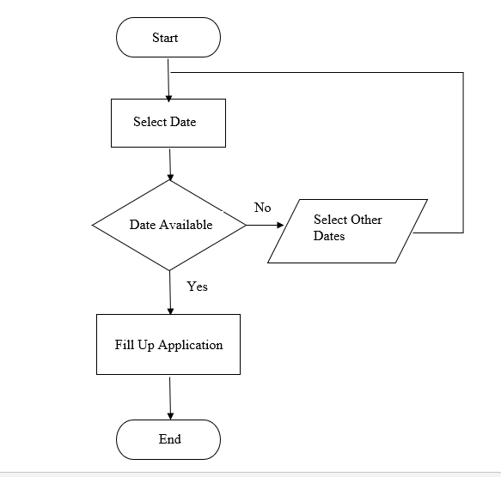

**Figure 3. Booking Admission Flowchart**

This flowchart outlines a booking procedure done on a booking reservation website page. It starts with the user selecting a date they would like to book. If the date is available, they proceed to the next step and fill out an application. If the date isn't available, they go back to the start and select other dates. The flowchart ends when the user has filled out their application.

Figure 4 displays the process on how the admin monitors and updates the website content.

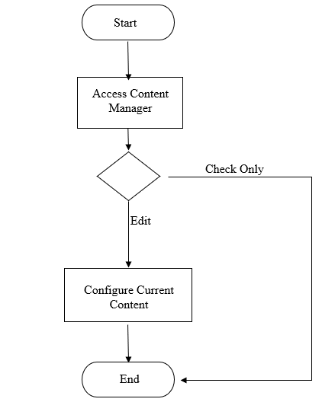

**Figure 4. Content Management Flowchart**

This flowchart outlines the process that an administrator would go through when monitoring and updating the content on a website. It begins with the administrator accessing the content manager. This flowchart provides a helpful overview of the process that an administrator must go through in order to monitor and update the content on a website. It ensures that the content is kept up to date and accurate, which is essential for a successful website.

Figure 5 shows the whole flow of the Admin/Webmaster view of the VirtualShrine website content management system.

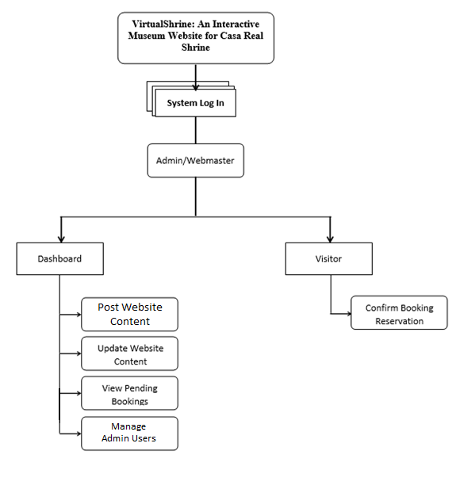

**Figure 5. Admin View VTOC**

This figure outlines the whole workflow, from creating and managing content to editing and managing users. All of these features are accessible from a single admin interface, allowing for quick and easy management of the VirtualShrine website.

**Context Diagram of VirtualShrine: An Interactive Museum Website for Casa Real Shrine**

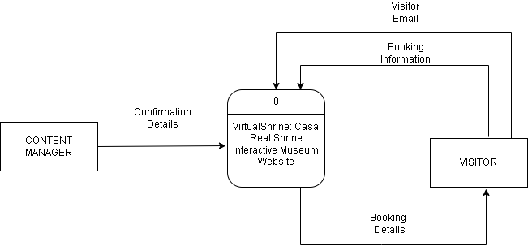Figure 6 illustrates the Level 0 of the Context Diagram; this context diagram shows the entities that interacted with the developed system.

**Figure 6. Data Flow Diagram Level 0**

The diagram shows the VirtualShrine website as the central element, with other entities such as visitors and content managers interacting with it. The diagram also shows the flow of data between these entities and the VirtualShrine website, such as the visitor initiating a booking and receiving confirmation emails and the content manager being able to process the booking and confirmation emails.

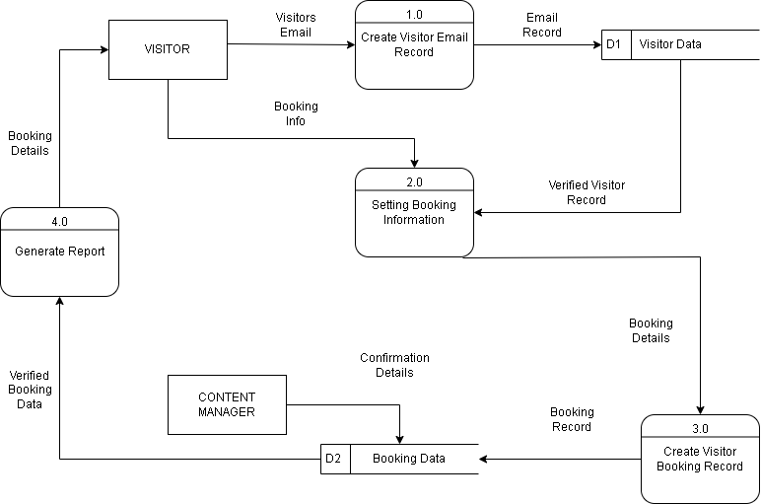Figure 7 shows Level 1 of Data Flow Diagram, the system displays the process specifically from the Visitors to the content manager/admin who will interact with the system.

**Figure 7. Data Flow Diagram (Level 1)**

In the diagram, a visitor initiates a booking process by providing book information to a setting Booking information. The setting Booking information then creates a Visitor Booking record and sends it to a Content Manager who confirms the Details of Booking Data. Once the data is verified, a report is generated with the booking details and sent back to the visitor. Finally, an email record is sent to the visitor.

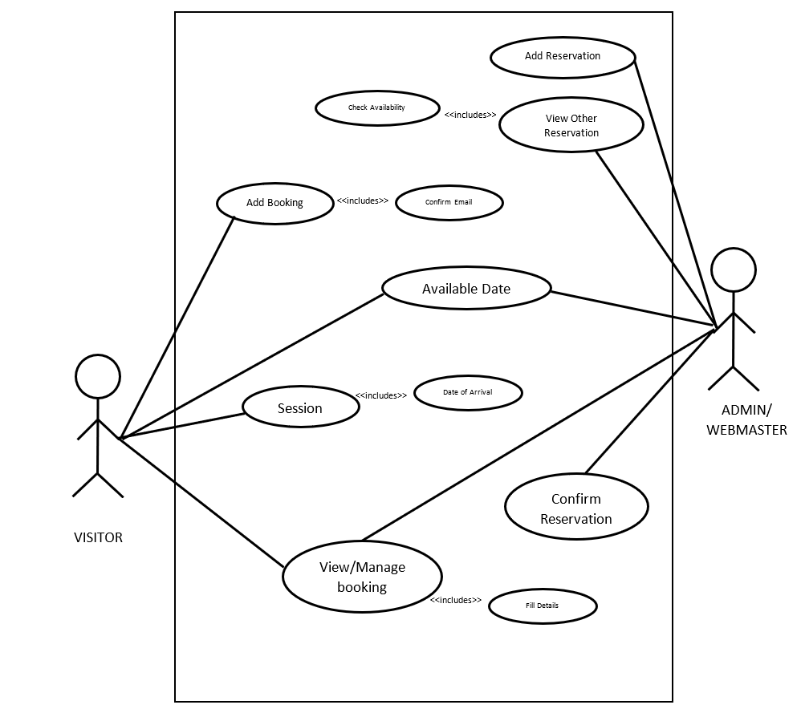 Figure 8 displays a use-case diagram which provides a visual representation of the interactions between a system and its users.

**Figure 8. Use Case Diagram**

This illustrates the context and objectives of the system, showing how the users interact with it in order to achieve their goals. The diagram also serves to identify potential problems and areas for improvement, helping to ensure the system meets user needs and expectations.

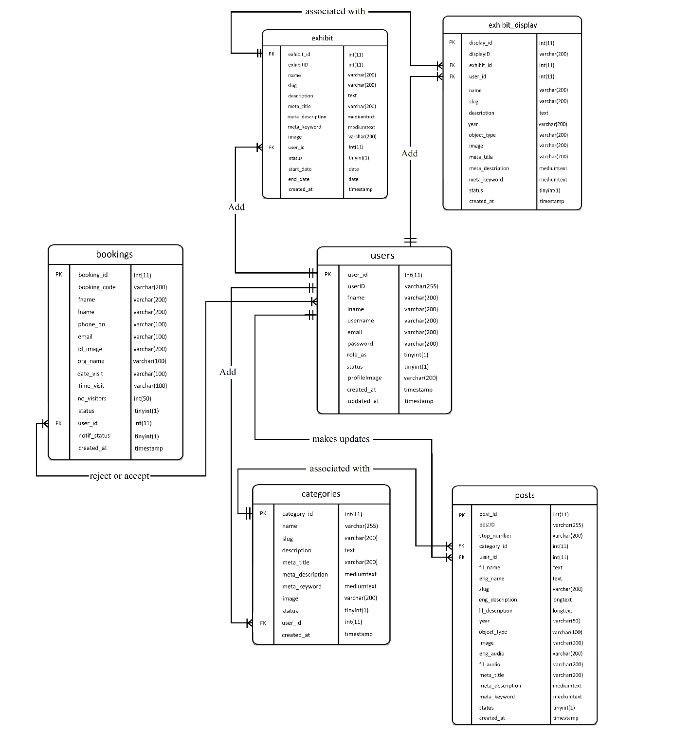Figure 9 shows different types of entities such as users, bookings, exhibit, exhibit display, categories, and posts.

**Figure 9. Entity Relationship Diagram (ERD)**

This figure shows the relationship between each entity and the flow of information inside the system. All the entities are interconnected with each other, providing an efficient way to access information which is essential for a better user experience. Moreover, this diagram also helps to understand how data is stored and managed in the system.

**Conceptual System Design**

The VirtualShrine: An interactive museum website for Casa Real is an interactive website that offers interactive features that would help the museum attract more visitors. One of the functionalities of the system is browsing the features and book reservation for the physical museum visit in the desired date and time of the visitors. Financial Transactions such as selling products from the museum gift shops are not included in this system. The system also does not require the visitor to register for an account, the only time that the system will ask for the visitor’s information is when they book for reservations.

**System Architecture**

**The Client’s Access to the Website**

Figure 10 shows the user’s access to the website via the internet through their computer terminal.

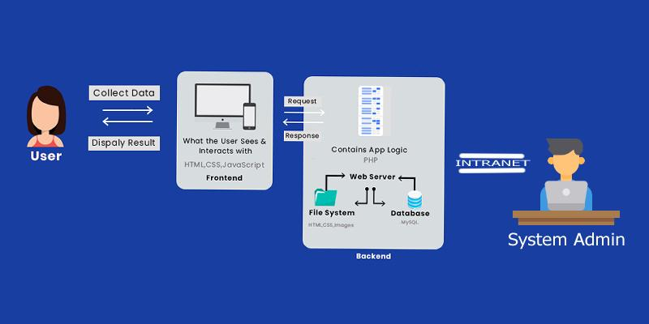

**Figure 10. The Client’s Access to the Website**

The web server replies and saves the client’s request to the database server.

The content manager can access the back office of the system via an intranet connection to maintain and update the system.

**Security Matrix**

Table 3 displays the Security Matrix. This security matrix applies only to the Back-Office application. The matrix shows the accessibility rights of every user of the system.

|  |  |  |  |
| --- | --- | --- | --- |
| **Module** | **Head**  **Admin** | **Assistance  Admin** | **User** |
| Log In | ✔ | ✔ |  |
| View All Booking Reservation | ✔ | ✔ |  |
| Approve/Decline Reservation | ✔ | ✔ |  |
| Upload/Update website content | ✔ | ✔ |  |
| View Website Content | ✔ | ✔ | ✔ |
| Add User | ✔ |  |  |
| View User Information | ✔ |  |  |
| Edit User Information | ✔ |  |  |
| Archive User | ✔ |  |  |
| Book Reservation | ✔ | ✔ | ✔ |
| Archive Contents | ✔ |  |  |
| Update Personal Profile | ✔ | ✔ |  |

**Table 3. Security Matrix**

This security matrix outlines the different levels of access that users have depending on the user hierarchy. Super Admins have full access to the system, Assistant Admins have access to Log In, View All Booking Reservation, Approve/Decline Reservation, Upload/Update website content, and View Website Content, and users have access to View Website Content and Book Reservation. This ensures that the system is secure and that the appropriate levels of access are given to the different user types.

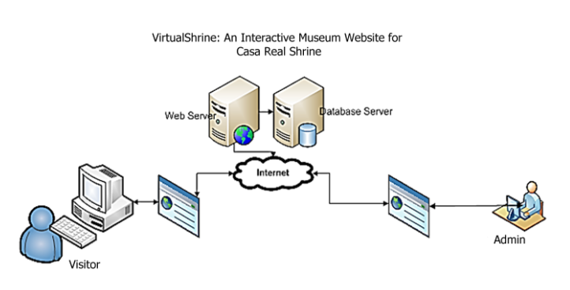The booking reservation process of VirtualShrine can be done through online transactions as shown in Figure 11. However, there are some instances that the visitor is not actually using the internet to make their reservation. They visit the museum as walk-in customers.

**Figure 11. Online Booking Process**

In order to handle the data that will be submitted by the customer, the system will use a database server which is directly connected to a web server for internet connectivity. Maintenance, modifications, and updates can be done by the administrator.

Figure 12 will show the illustration for the walk-in admission process.

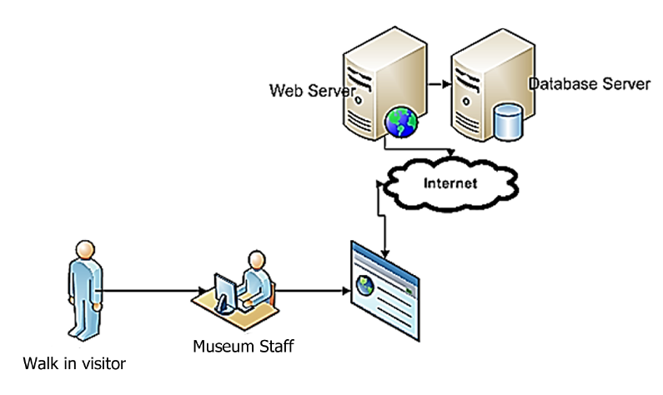

**Figure 12. Walk-in Admission Process**

For the customer to make visiting admission, the following steps must be followed:

Step1: Customer inquiries at the Museum staff about the visiting slot availability.

Step 2: The Museum staff will log in to the System Back Office. He will ask for the date of reservation and what to reserve. Using the System, the museum staff can give the availability of the admission slots.

Step 3: Once the visitor decides to book for admission, the clerk will ask the user the basic information for profiling purposes.

**Network Infrastructure**

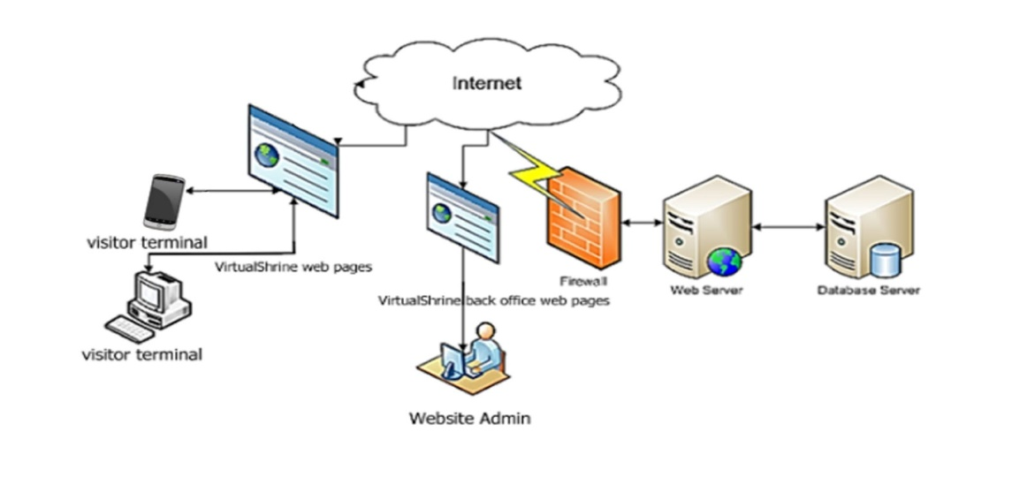Figure 13 will show the network infrastructure of the VirtualShrine Website.

**Figure 13. The Network Infrastructure**

Since the proposed system is an interactive website, Internet connection is particularly important. As can be seen from the figure (Fig. 18), the visitor can browse the VirtualShrine website, and their reservation can be made.

Also, the system will allow website visitors to search for museum information such as operation hours and location from the museum website.

On the part of the Administrator (back-office account), the system will allow the Website Manager (administrator) to make modifications including updating the contents of the website. They can also approve and reject a booking from the visitor.

**The Developed System**

Development of the VirtualShrine website for Casa Real Shrine included an Online Booking system, Virtual Museum tour, Gallery Collections, and User assisting features, all with user experience in mind. Content and navigation rules were established to make navigating the system easier.

Figure 14 shows the Homepage for the VirtualShrine website, which will act as the entry point for all visitors.

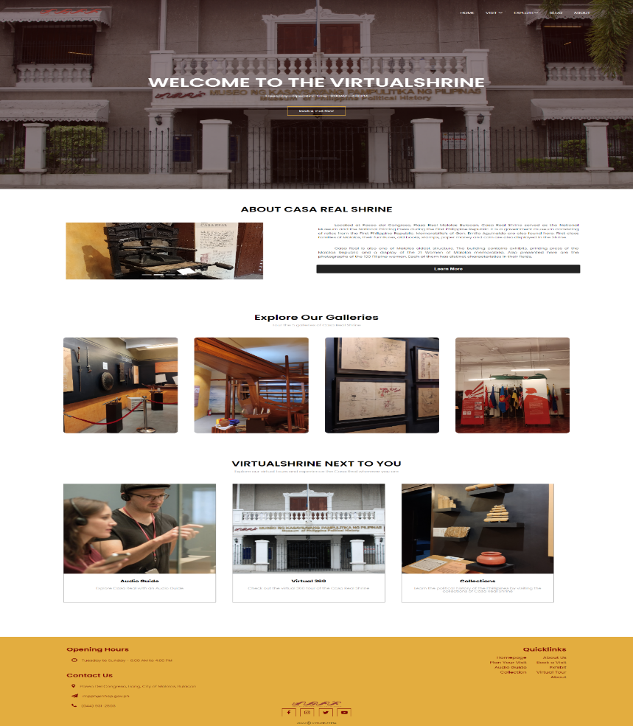

**Figure 14. VirtualShrine Homepage**

This page contains important information about the site, including brief information about the Casa Real Shrine, as well as links to other pages and resources. Visitors will be able to find their way quickly and easily around the site and learn more about the services and offerings the website provides.

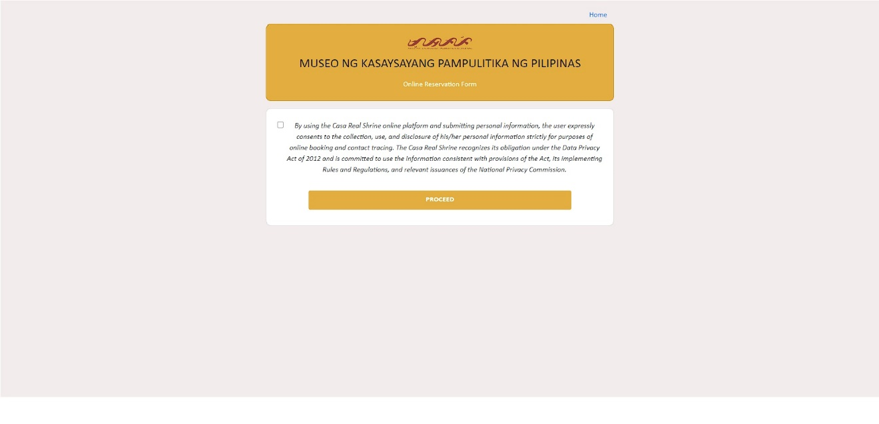 Figure 15 displays the Booking Consent form. The visitor will be redirected to this page once they click the Book Now button found on the banner of the homepage.

**Figure 15. VirtualShrine Booking Consent Form**

This page will provide the visitor with the terms and conditions regarding their booking. By agreeing to the terms and conditions and submitting the form, the visitor will be able to proceed to the next page.

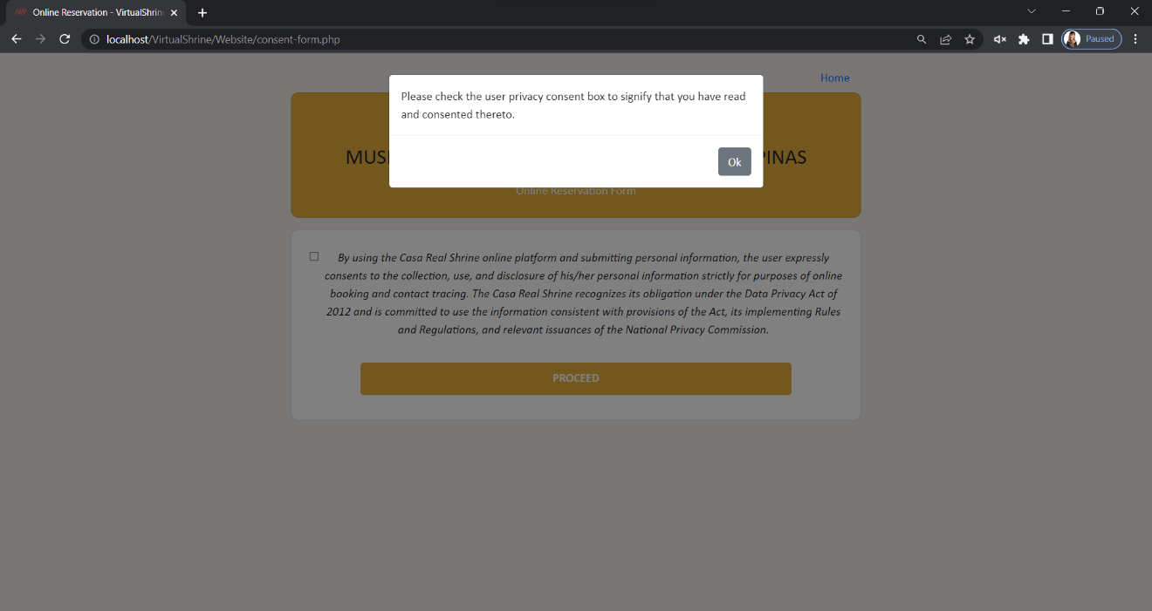 Figure 16 illustrates a popup warning message that appears when a visitor clicks the 'proceed' button without checking the checkbox.

**Figure 16. VirtualShrine Booking Consent Form – Warning Message**

The popup message appears to remind the visitor to check the checkbox. Once the checkbox is checked, this indicates that the visitor understands the terms and conditions of their booking and has given permission for their personal data to be used.

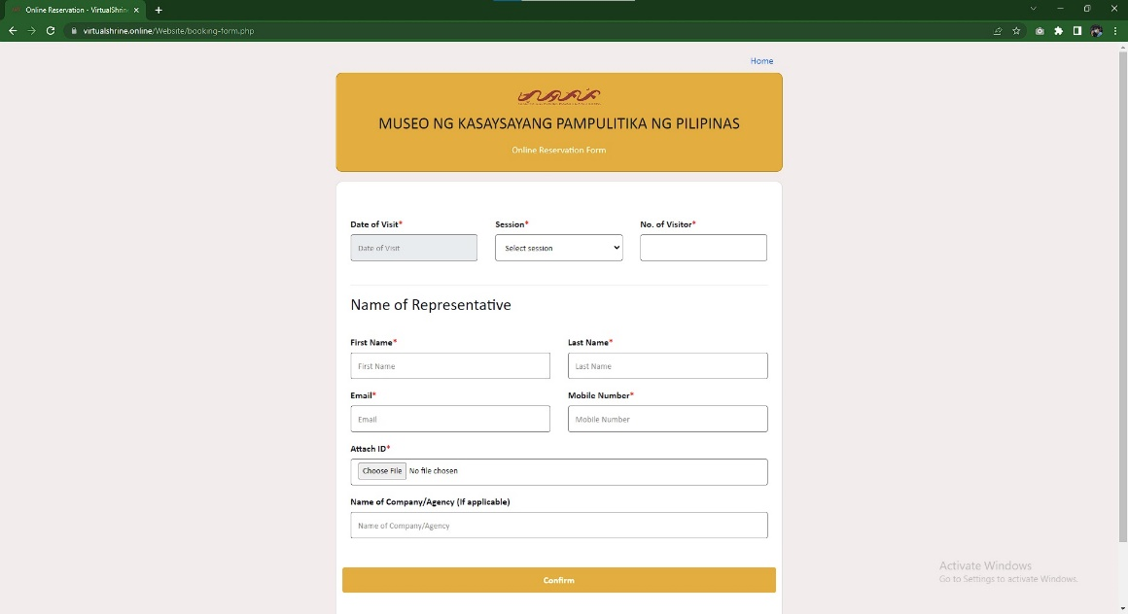Figure 17 displays the Booking form that visitors can complete with all the necessary information to make their reservation.

**Figure 17. VirtualShrine Booking Form**

The form requests Date of Visit, Session, No. of Visitors, First Name, Last Name, Email, Mobile, valid ID photo and organization (optional).

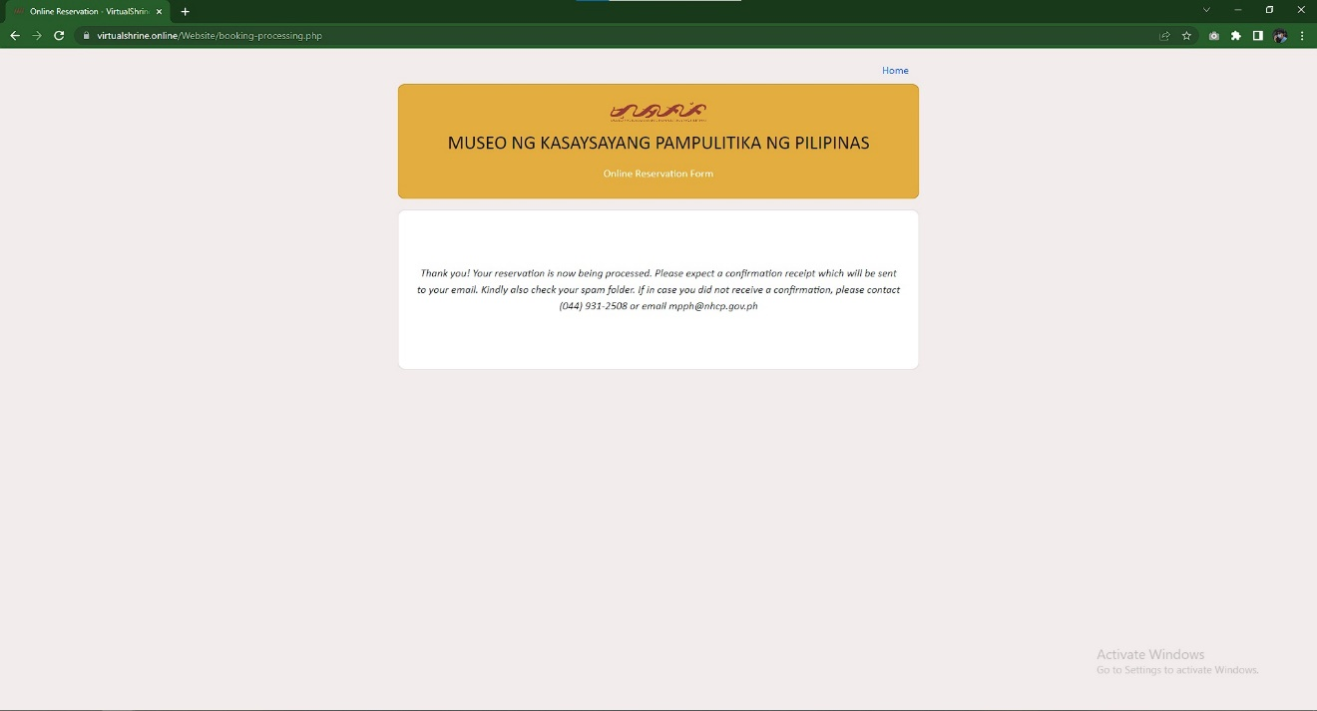Figure 18 illustrates the final page of the booking process, which indicates that the visitor's booking has been received and reviewed by the administrator.

**Figure 18. Booking Submitted Confirmation Page**

If all the information provided by the visitor is accurate and valid, the booking can be confirmed.

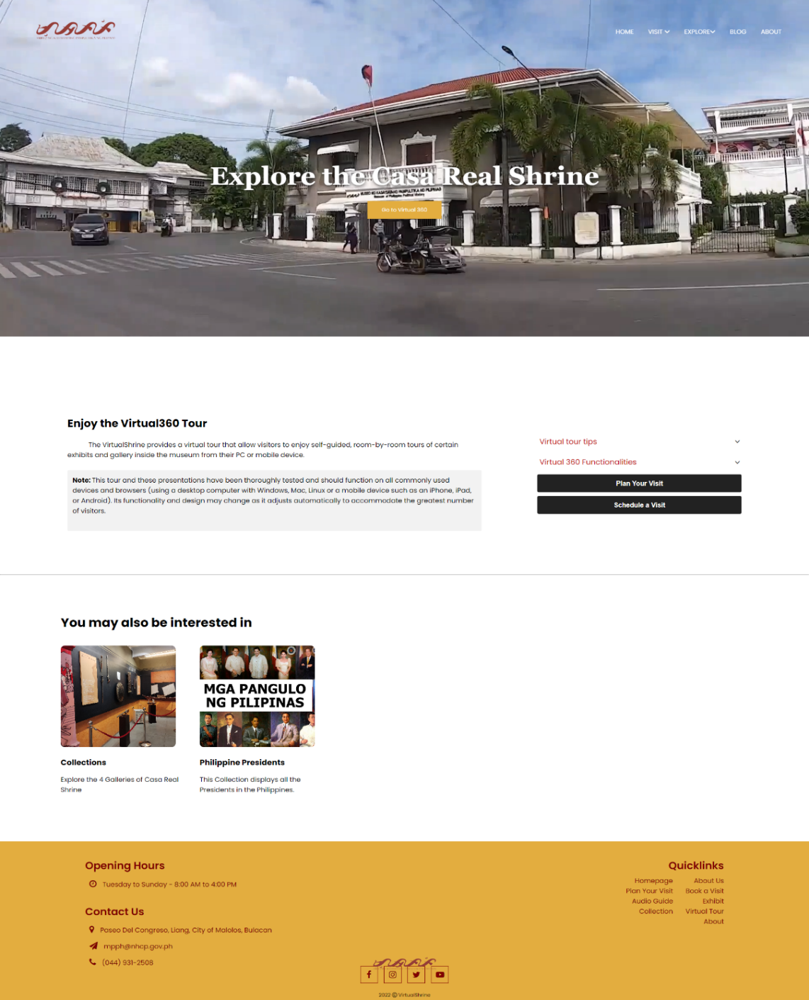 Figure 19 displays the access to the Virtual Tour page.

**Figure 19.** **Access to the Virtual Tour Page**

This page provides a portal to the Virtual 360 view of the museum, giving users an immersive 360-degree view of the museum's many galleries, exhibits, and artifacts. It also includes a brief overview of the features and functionalities of the Virtual Tour, as well as some helpful tips on how to make the most out of the experience.

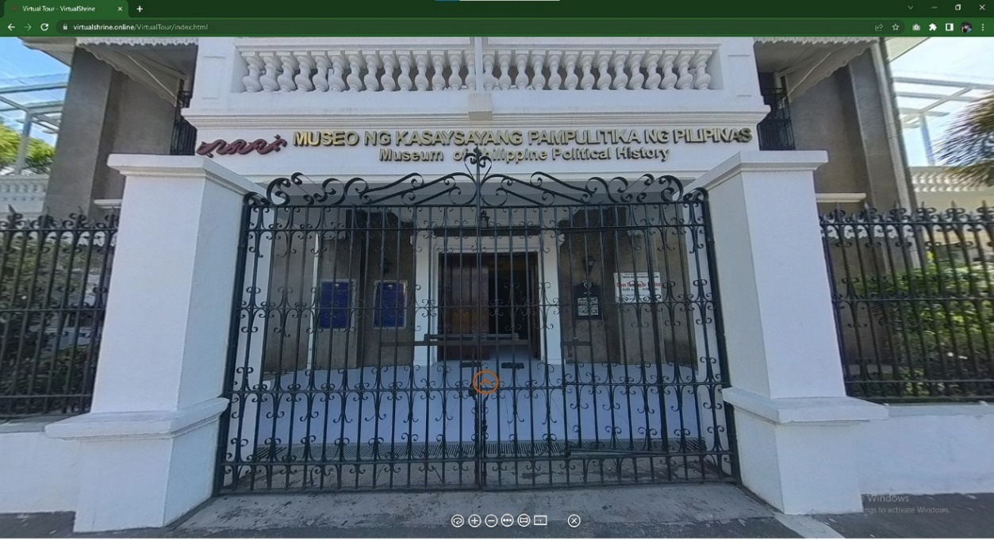Figure 20 displays the landing page when the user opens the virtual tour.

**Figure 20. Virtual 360**

This page showcases the Casa Real Shrine's main gate, with a yellow door icon as the hotspot to access galleries. Visitors can explore the virtual tour at their own pace and see all the incredible sights.

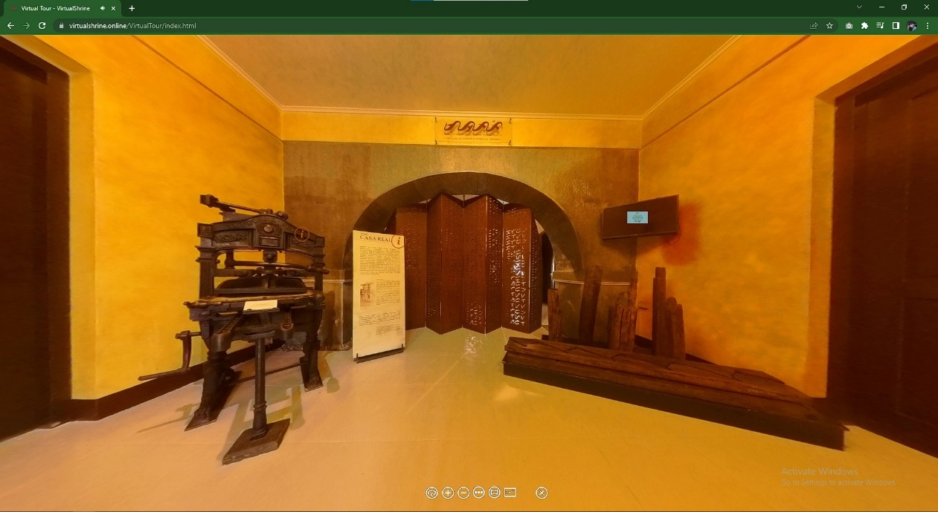Figure 21 illustrates the Virtual Tour lobby; the first room visitors enter when they come to the museum.

**Figure 21. Virtual Tour Lobby**

By swiping left and right, they can take in the sights of the area and interact with the different hotspots available, which provide further information on the museum. If a hotspot is pressed, a pop-up will appear with a definition of the display.

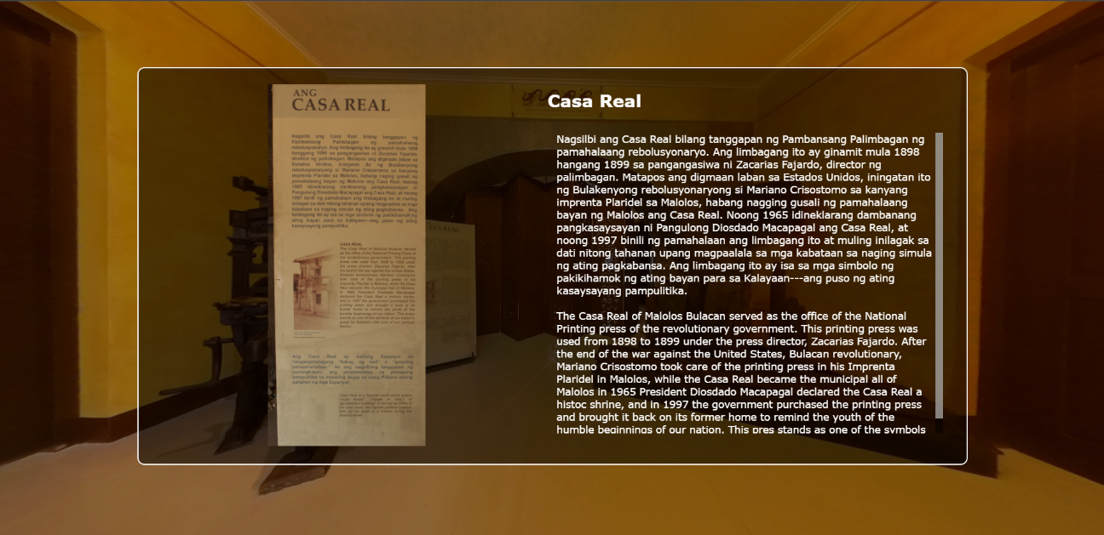Figure 22 displays the info popup which is shown as a small window containing an image and a description of the object displayed.

**Figure 21. Virtual Tour Info Popup**

This hotspot popup is used to provide more context and detail to the virtual tour, making it easier for viewers to learn more about the objects or locations featured in the tour.

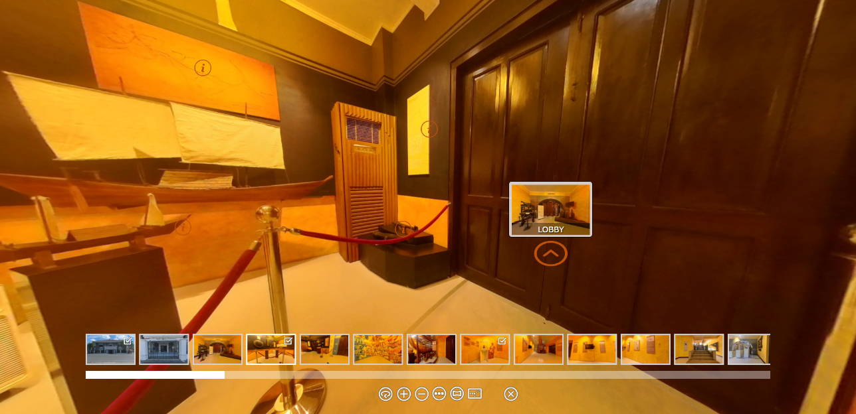Figure 22 shows the Virtual Tour controller found at the bottom of the screen.

**Figure 22. Virtual Tour Controller**

This controller helps visitors navigate the 360° tour. This controller includes Zoom In, Zoom Out, Auto Rotate, Show User Date, Thumbnail Menu, enter to full screen, and exit to virtual tour.

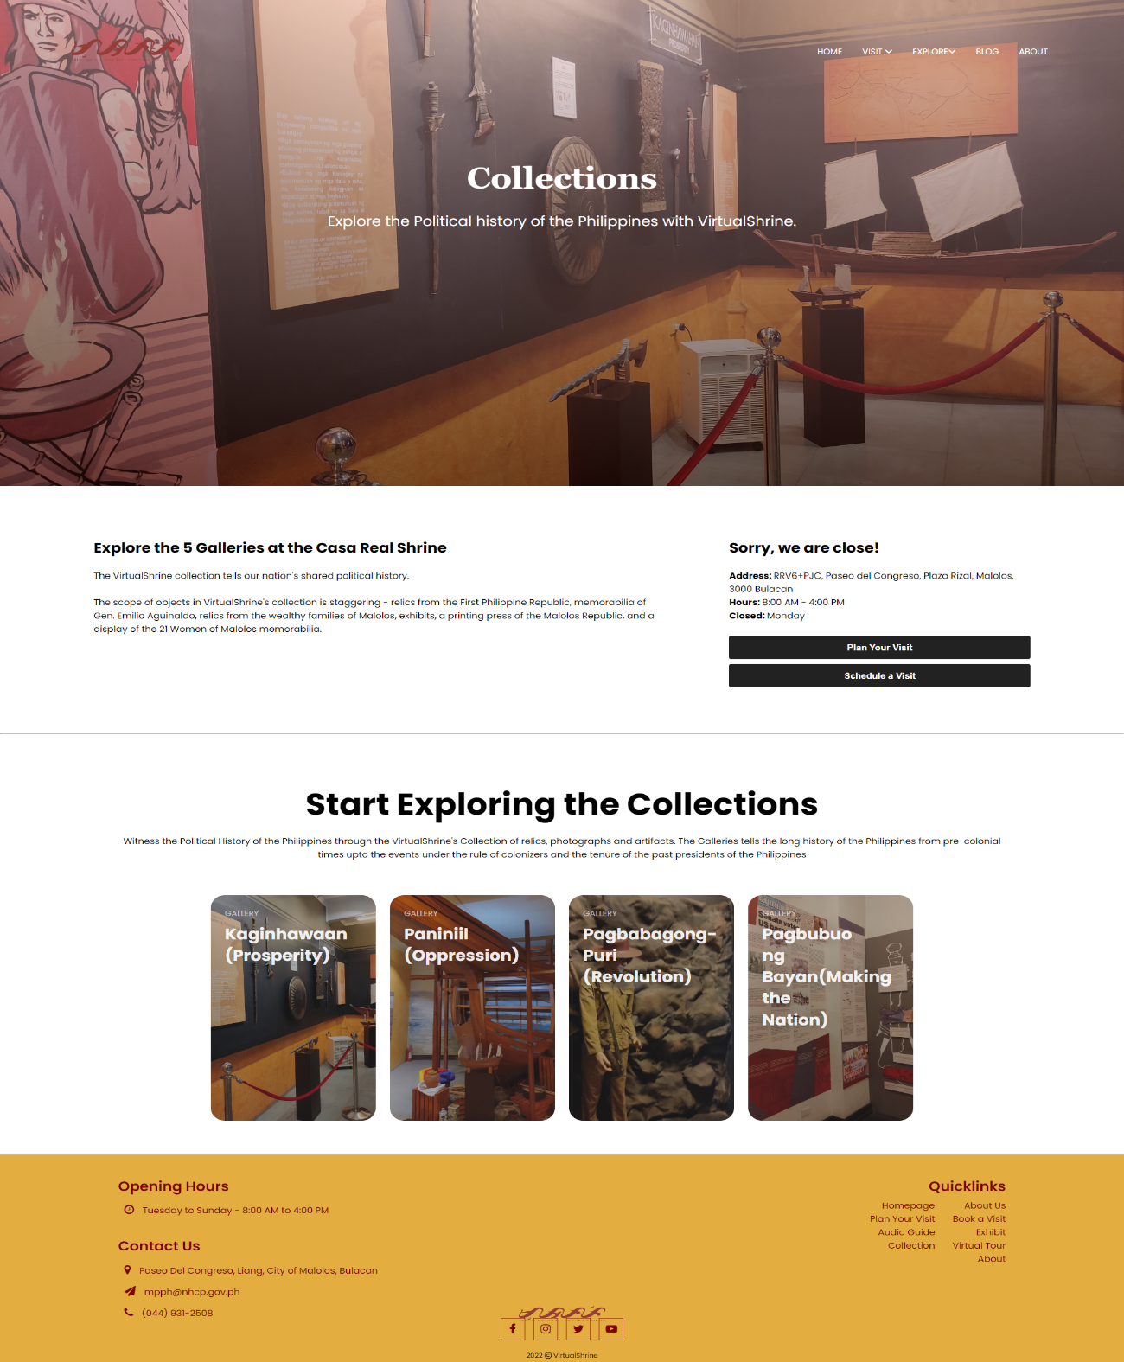Figure 23 shows the Gallery page. This is where different galleries can be accessed by the visitors.

**Figure 23. Gallery Page**

This page displays the 4 galleries in the museum. Every cards lead to different rooms in the museum like Kaginhawaan(Prosperity), Paniniil(Oppression), Pagbabagong-puri(Revolution), Pagbuo ng bayan(Making the nation).

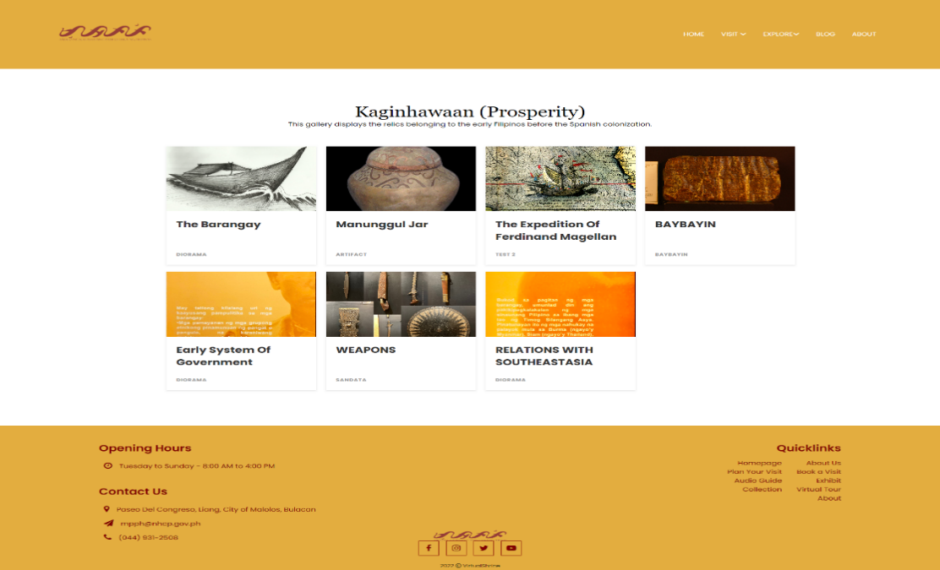Figure 24 displays the Galleries Collection page. This page is where the visitors can view the different collections found on each museum gallery.

**Figure 24. Galleries Collection page**

The page is designed for easy navigation, displaying collections in a grid with each featured as image and title. Clicking on the image provides more info.

Figure 25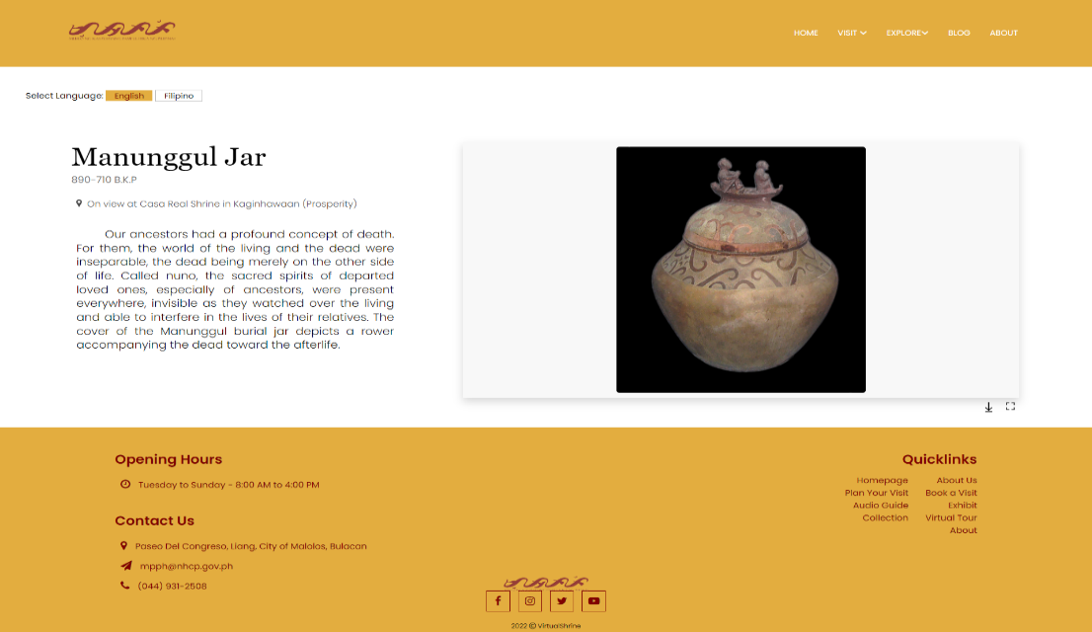. The visitor will be redirected to the Display Description page as shown in Figure 25 once they click an image title from the Gallery Collection Page.

**Figure 25. Display Description page**

This page provides visitors with detailed information on the display, including the ability to download and print a picture of the artifact and its accompanying description.

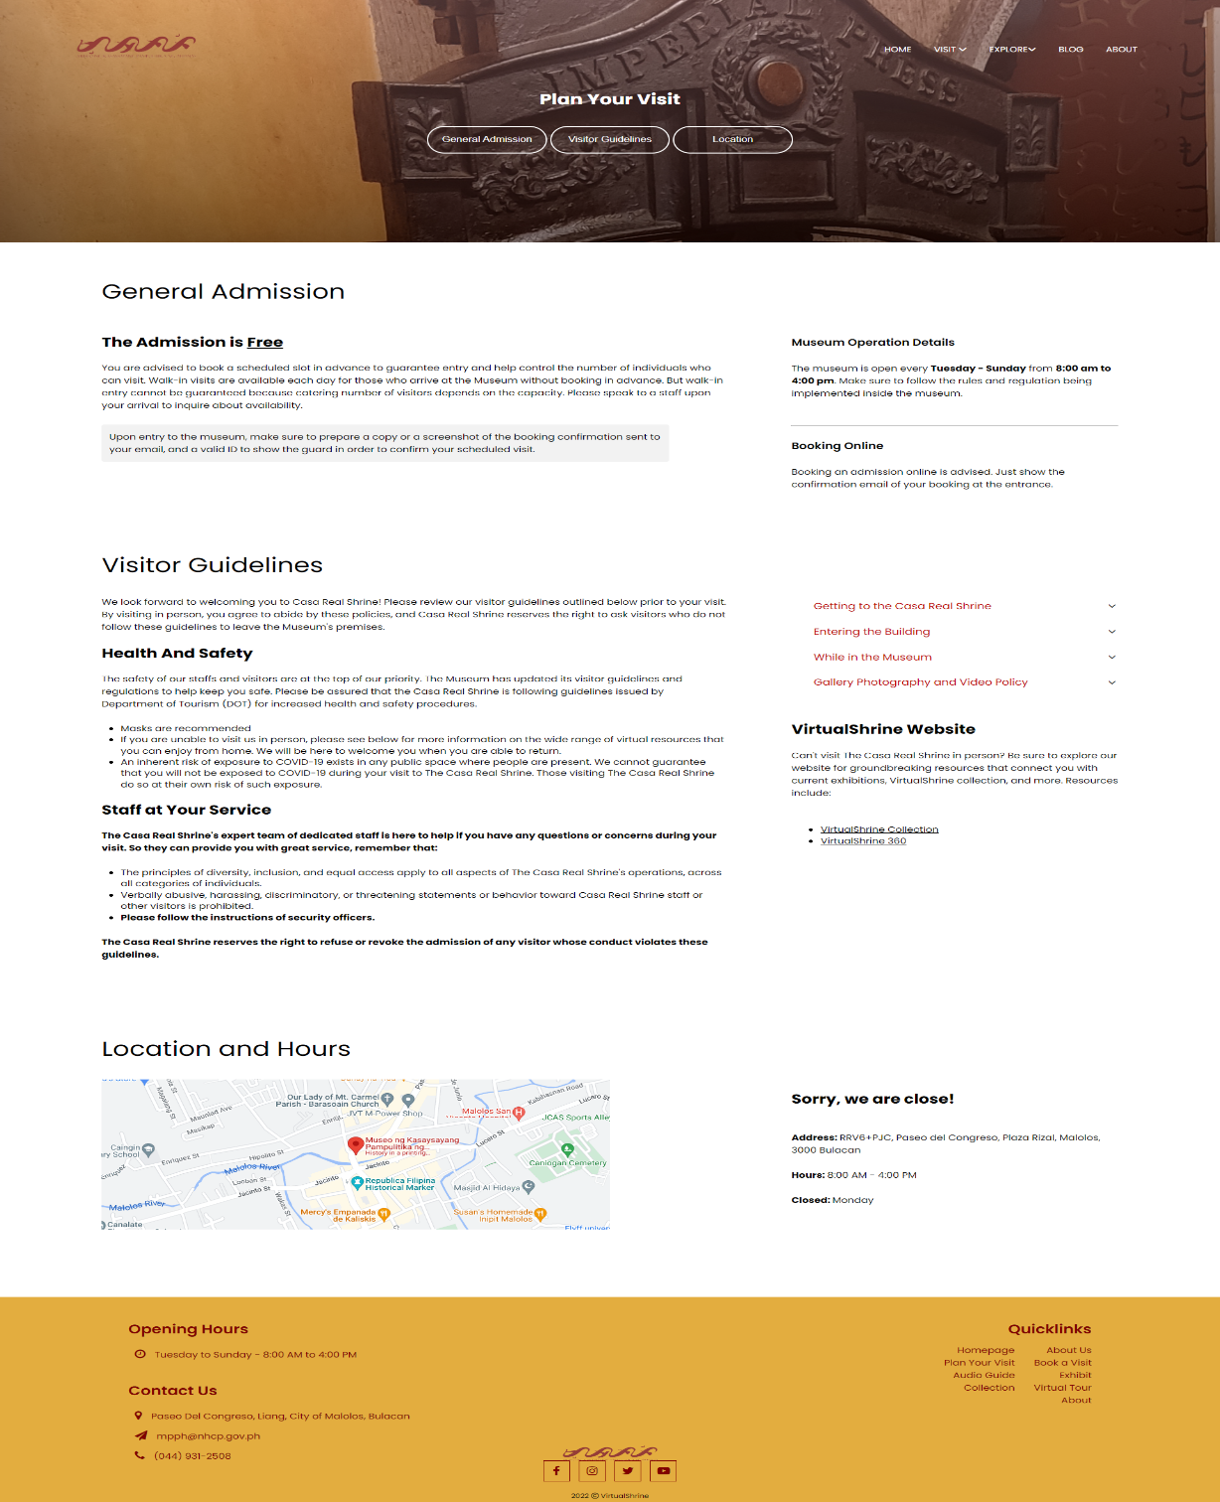Figure 26 shows the Plan Your Visit page of the VirtualShrine, which provides information and resources to help visitors plan their trips.

**Figure 26. Plan your Visit page**

This page allows users to easily find information on hours of operation, admission process, directions, accessibility, and other necessary details they need to plan their visit. This page also outlines the visitor guidelines that visitors must adhere to during their visit. This page is an essential part of the museum-going experience, as it helps visitors plan their visit, get the most out of their experience, and ensure they abide by the museum's visitor guidelines.

Figure 27 displays the VirtualShrine Exhibitions page. This page provides information about the current, upcoming, and past exhibitions in the museum.

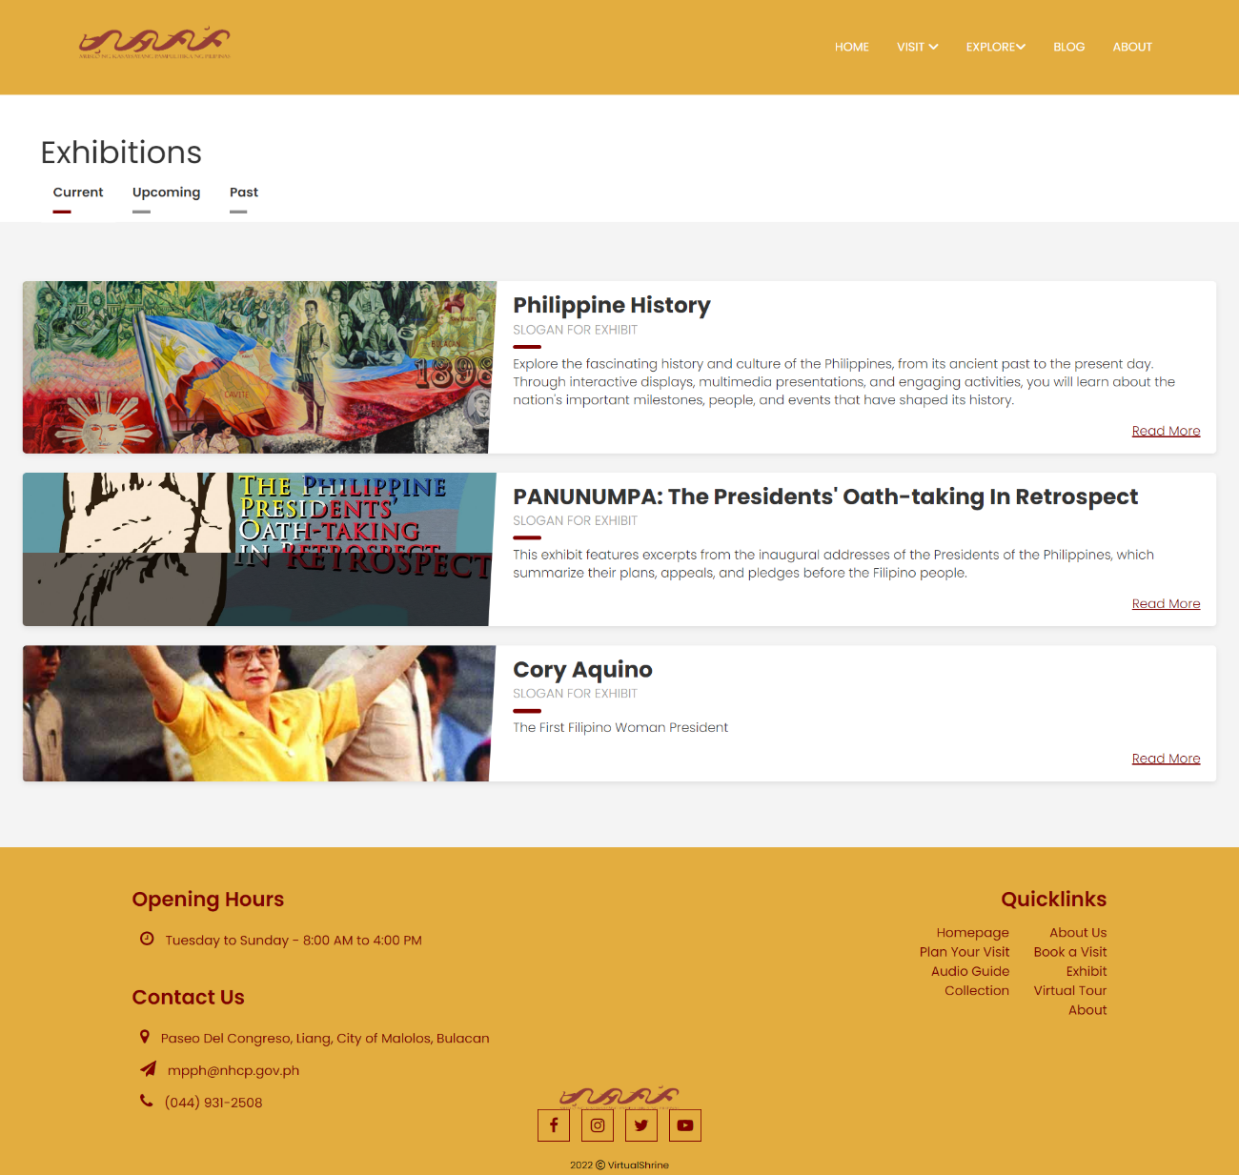**Figure 26. Exhibitions page**

The page is designed in an intuitive way, with the current, upcoming, and past exhibitions all separated into individual tabs, allowing visitors to easily navigate between the different exhibitions.

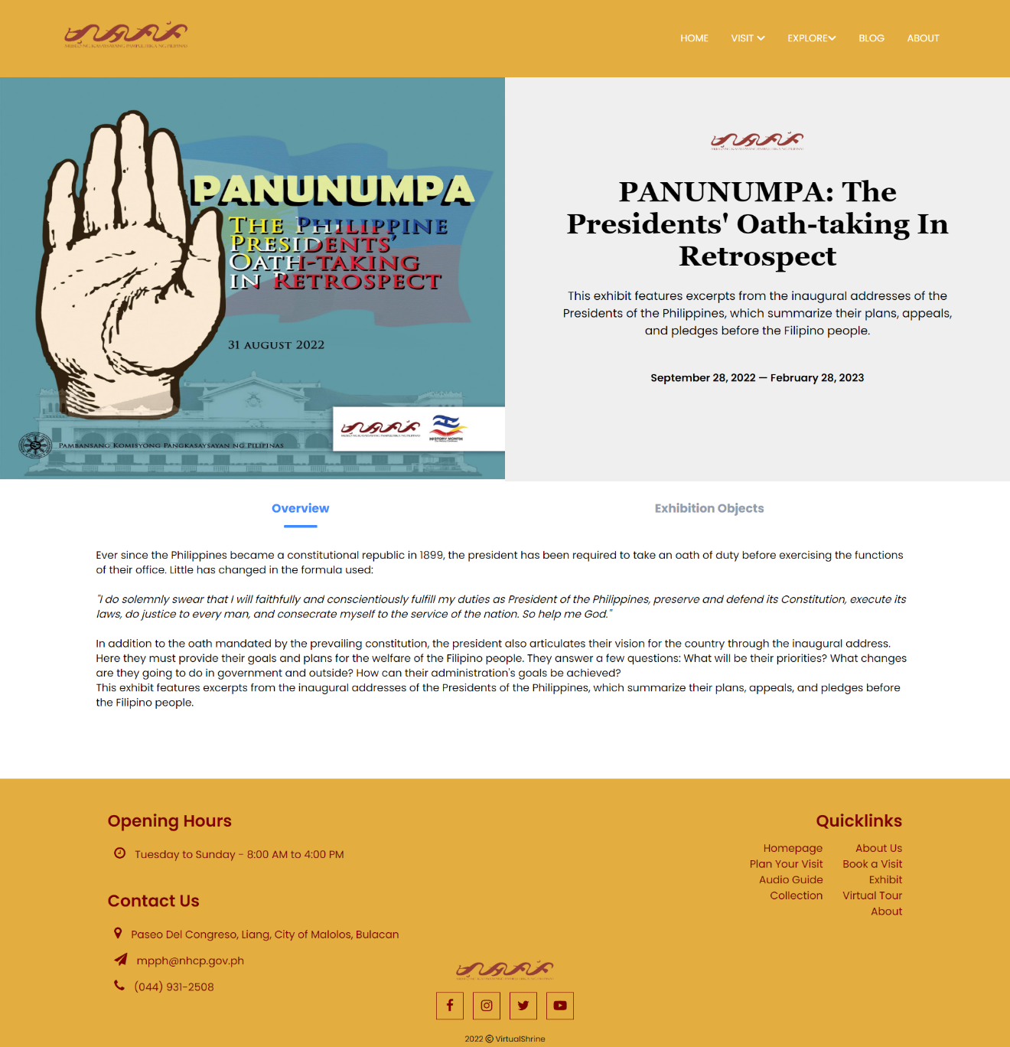Figure 27 displays an overview of the Exhibition, providing attendees with a comprehensive look at the different exhibits and attractions available.

**Figure 27. Exhibition Overview page**

This page provides visitors with a comprehensive overview of the exhibition, including its purpose, content, and displays. It also offers detailed information on the exhibition's historical context. Furthermore, it provides visitors with important information on how to visit the exhibition and any associated events. By exploring this page, visitors will gain an in-depth understanding of the exhibition, allowing them to make the most of their visit.

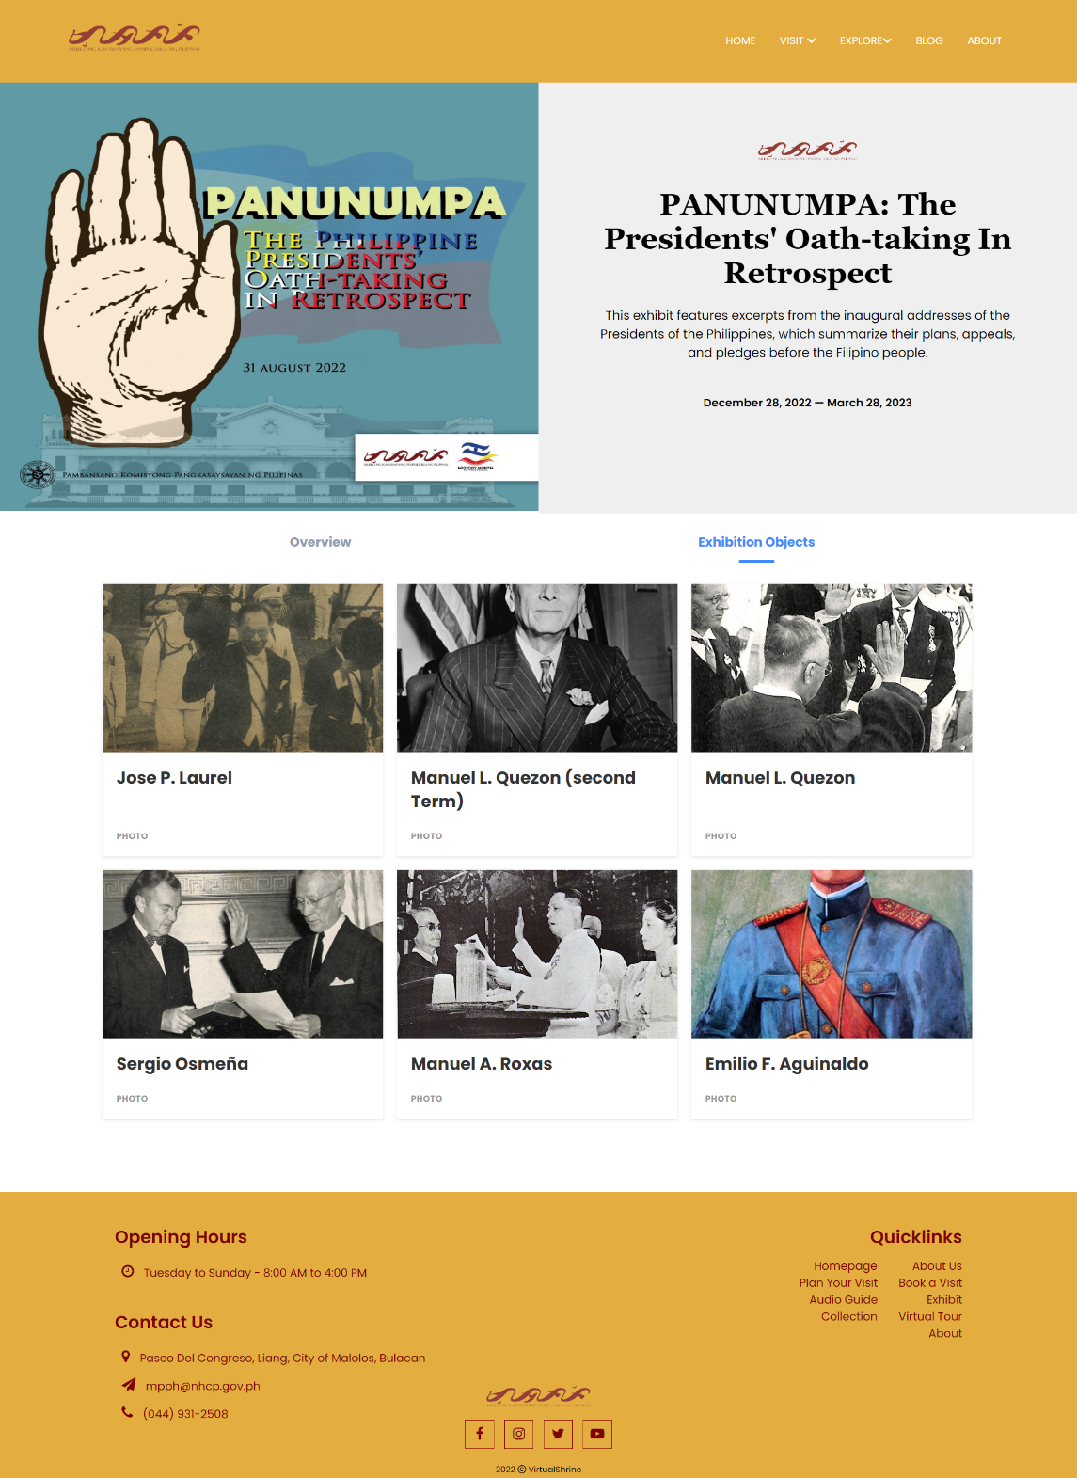Figure 28 shows a page of the objects featured in the Exhibition.

**Figure 28. Exhibition Objects page**

The page is designed to be user friendly and intuitive, providing visitors with an easy means to navigate through the objects. The page features an organized grid of images and titles, with each image representing the object. By clicking on the image, visitors are provided with more information about the object.

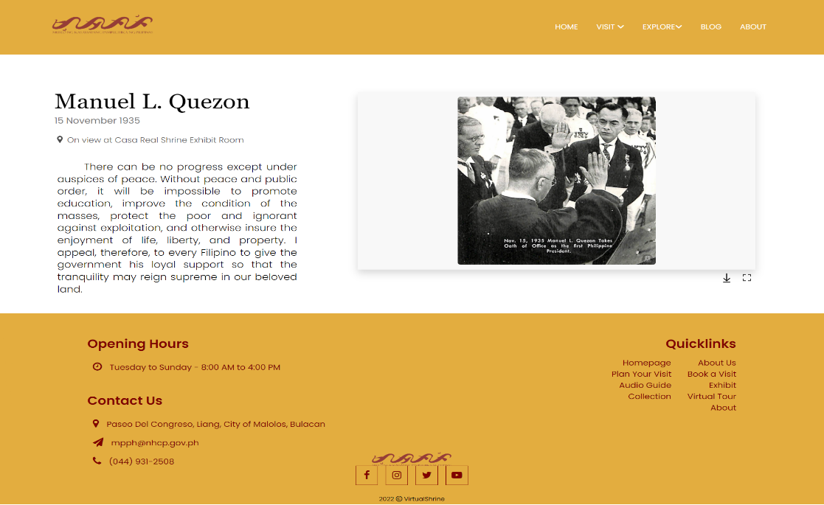When a user clicks an image title on the Exhibition Object Page, they will be redirected to the Exhibit Object Description page, as depicted in Figure 29.

**Figure 29. Exhibit Objects Description page**

This page contains a brief description of the object along with an image associated with it. Additionally, visitors will have the option to download and view a larger version of the image.

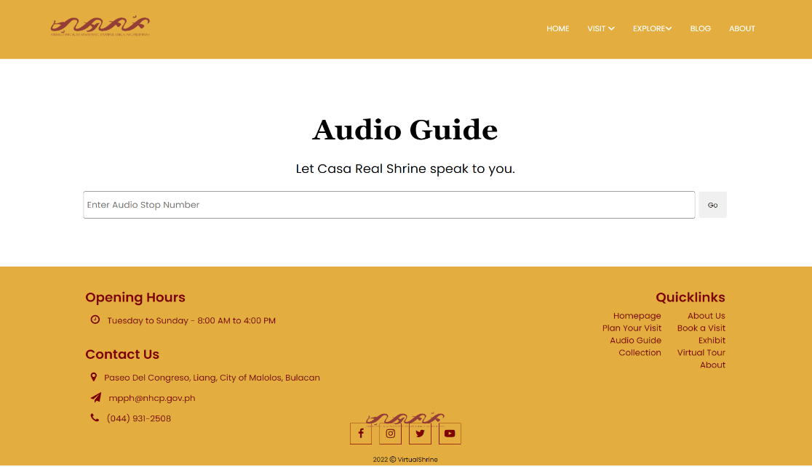Figure 30 displays the Audio Guide page.

**Figure 30. Audio Guide page**

This page provides a search bar for visitors to easily access audio recordings related to each museum display. Simply enter the display stop number to quickly access historical information and gain a deeper understanding of the museum collection.

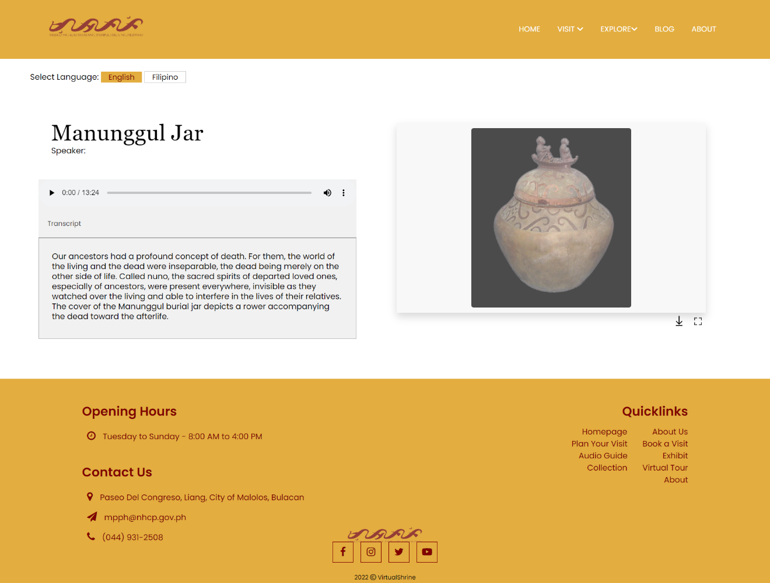Figure 31 displays the Audio Guide Player. This page is where the visitor will be able to listen to the audio related to the displayed object.

**Figure 31. Audio Guide Player**

The page includes an audio player, a preview image of the object, and the option to choose between English and Filipino language. The intuitively designed audio player allows visitors to adjust the volume, pause the audio, and even skip to different parts of the audio, making it easier to enjoy the audio description. Additionally, a transcript of the audio is provided to ensure that all visitors, regardless of their hearing abilities, are able to gain an understanding of the object on display. The transcripts are designed to be easy to read and understand, and the language used in both the audio and transcript will depend on the language chosen by the visitor.

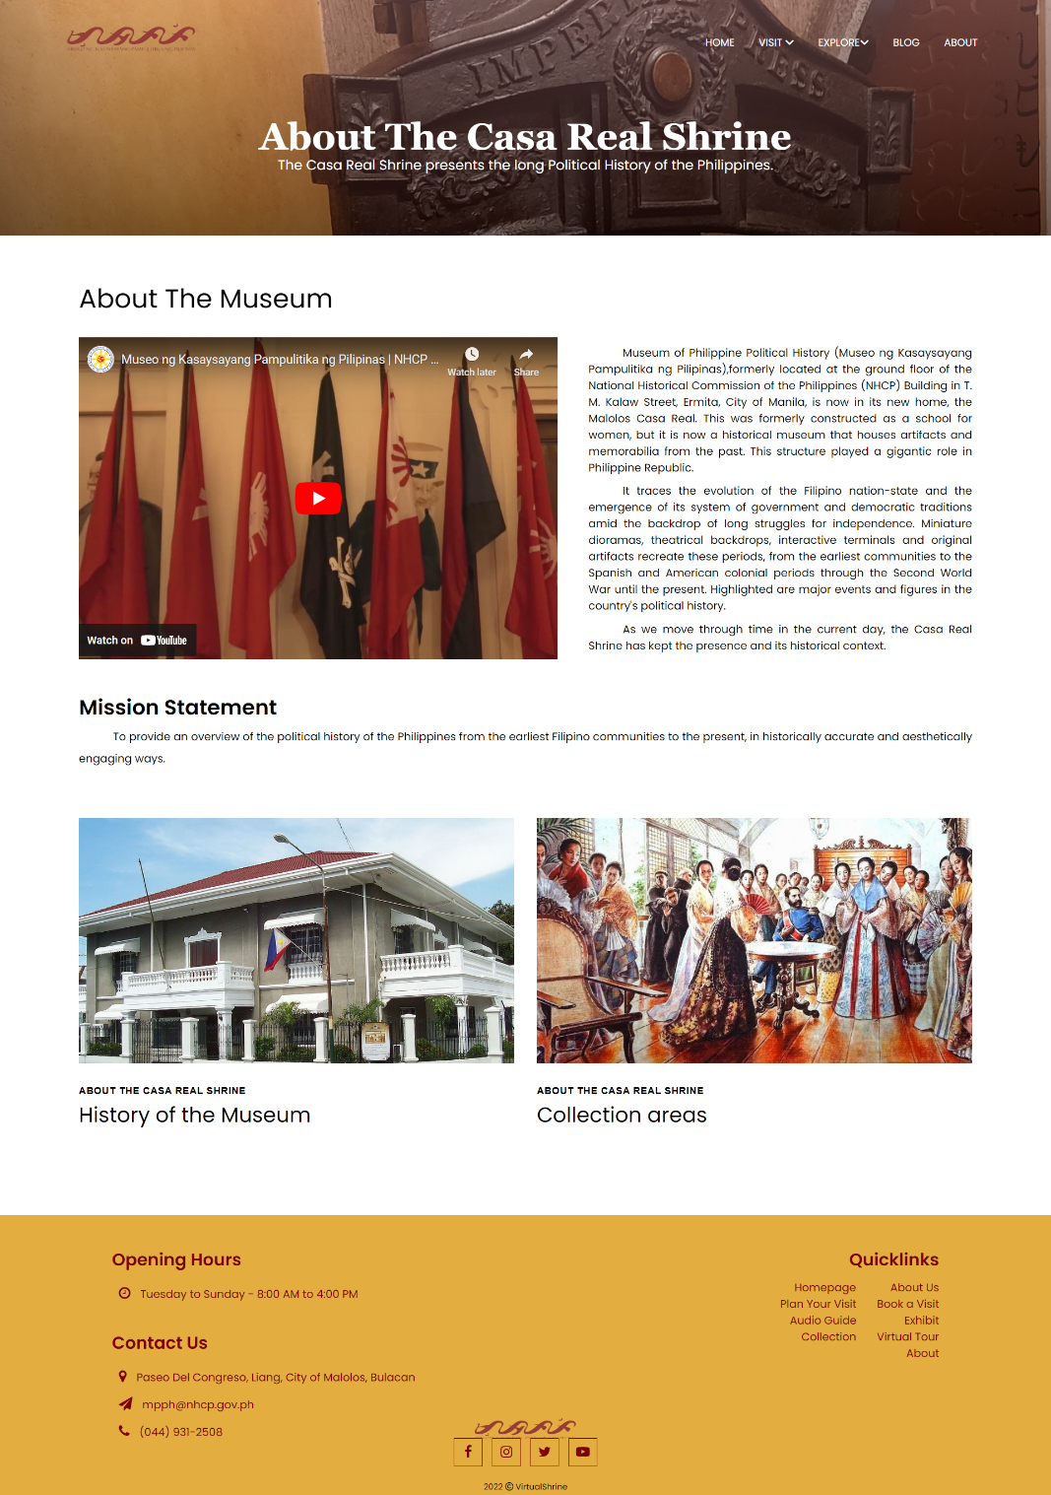Figure 31 displays the About page of the museum, providing visitors with an overview of the institution's history and mission.

**Figure 32. About page**

The mission statement outlines the museum's core purpose, while the brief history highlights the museum's journey to becoming the cultural hub it is today. A video presentation of the museum can also be viewed on this page.

A back-office system was created to manage User Admins, accept/reject Visitor bookings, upload website content, generate/print Admin Activity Reports and send Booking confirmation emails.

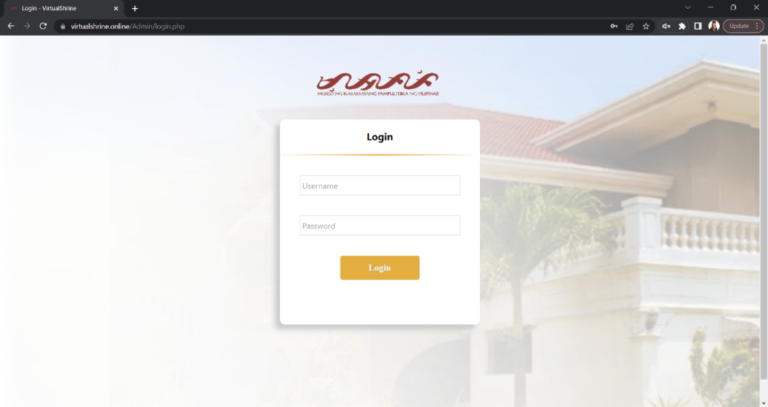Figure 33 displays the Login page of the Admin Dashboard, which allows the user to access the administrative page by entering the credentials they have created.

**Figure 33. VirtualShrine Admin Login Page**

The page features two text boxes where the user can enter their username and password respectively, as well as a 'Log In' button to submit the information.

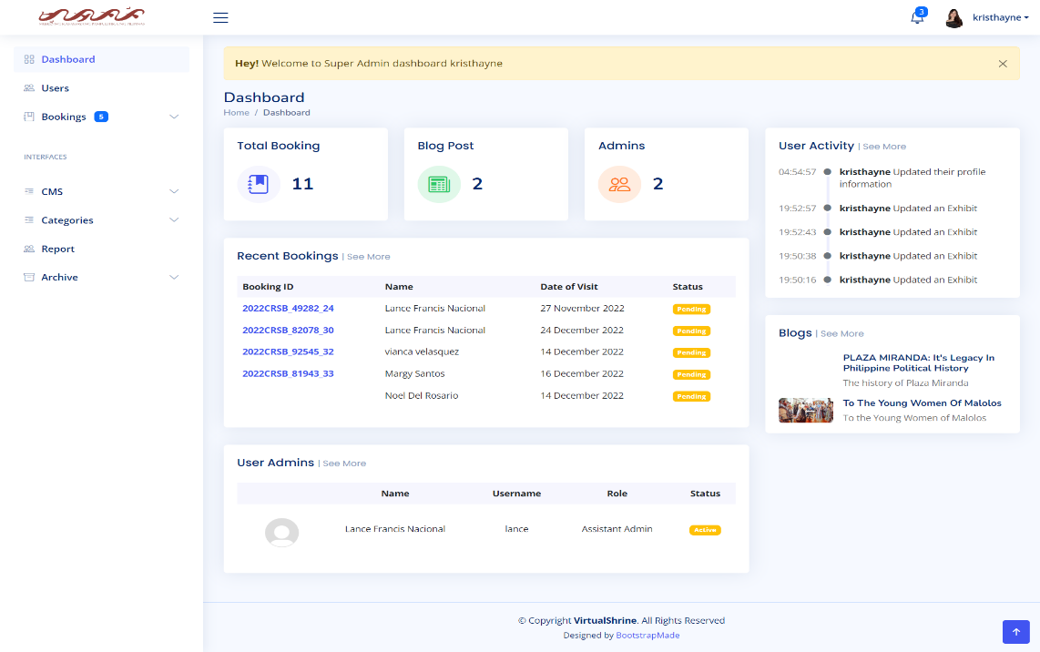Figure 34 illustrates the Admin Dashboard, allowing administrators track user activity, manage system settings, and access other administrative tools.

**Figure 34. VirtualShrine Admin Dashboard**

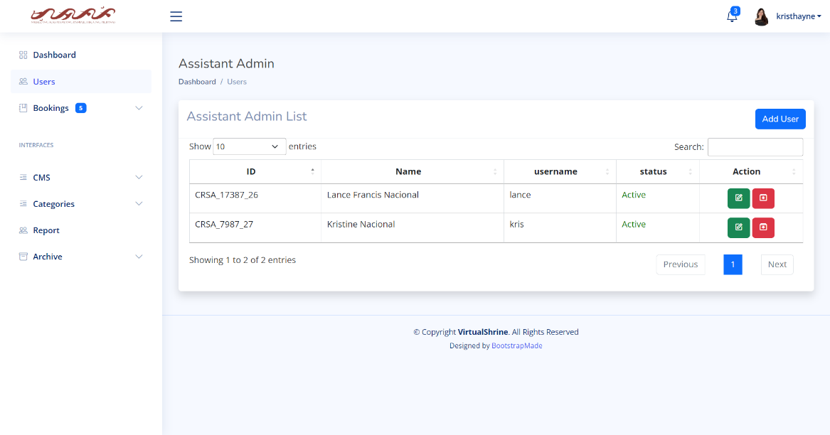Figure 35 shows the Assistant Admin Management panel, which is a tool used to manage assistant admin accounts.

**Figure 35. VirtualShrine Assistant Admin Management Panel**

Only the Super Admin (Museum Curator) can access this panel to add, edit, and archive users, and grant/revoke access for assistants. It also provides an overview of assistant admin accounts.

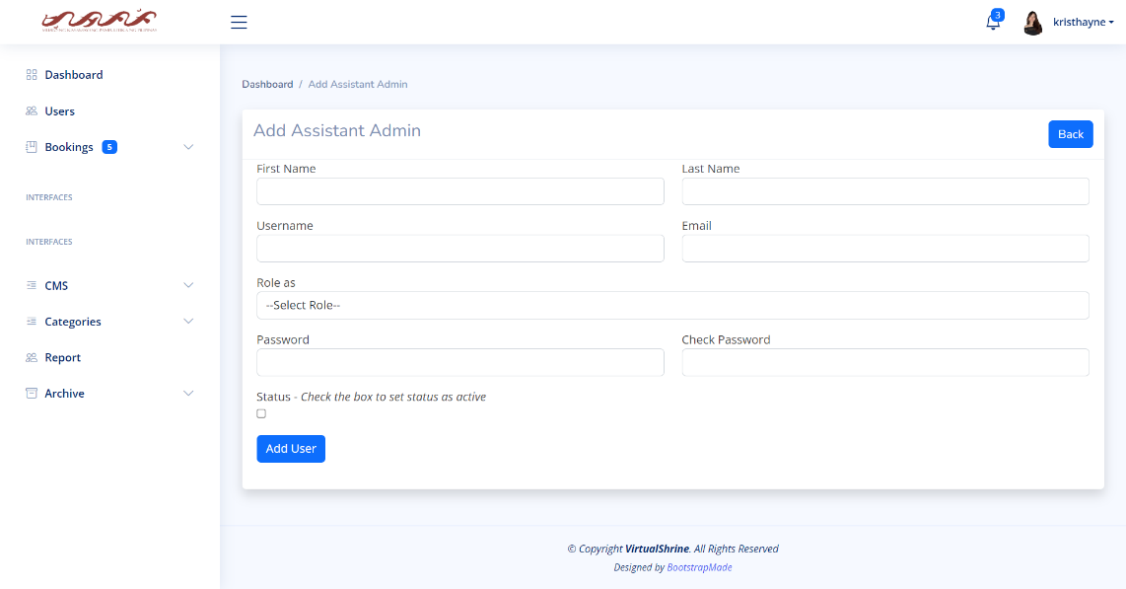Figure 36 shows the Add Assistant Admin form, which allows a user to add an assistant administrator to the system.

**Figure 36. Add Assistant Admin form**

This form can only be accessed by the super admin. The form contains fields for entering the user's name, username, email address, and password. The form also allows the Super Admin to select the appropriate roles and privileges for the new user. Once the necessary information is entered, the user can submit the form to complete the process.

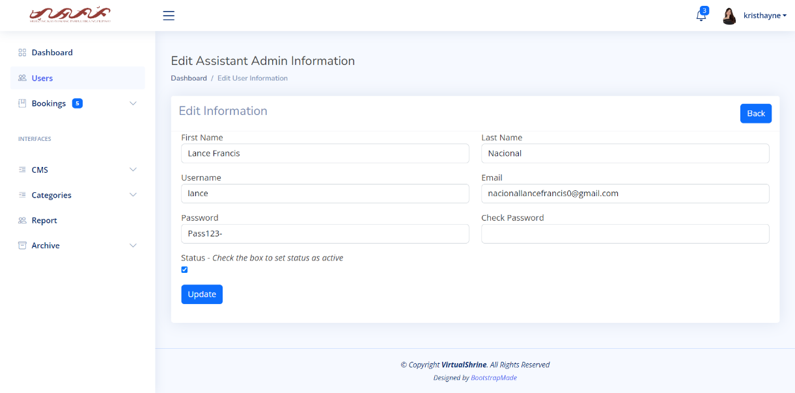 Figure 37 displays the Edit Assistant Admin Information form.

**Figure 37. Edit Assistant Admin Information form**

This form is used to update the details of an assistant administrator, such as their name, username, email address, and password. It also allows the Super Admin to change the administrator's active status. The form provides a convenient way for Super Admin to manage the assistant administrators.

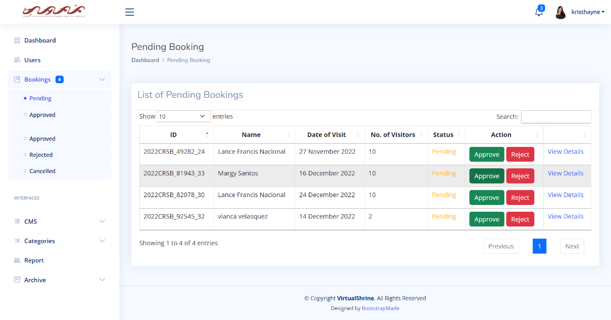Figure 38 illustrates the Pending Booking panel, which allows users to view a list of bookings that have not yet been processed.

**Figure 38. Pending Booking panel**

This panel provides a summary of each booking, including the visitor’s name, the number of visitors, and the desired dates of stay. Additionally, the panel allows users to approve or reject these bookings, thereby enabling them to manage their bookings more efficiently.

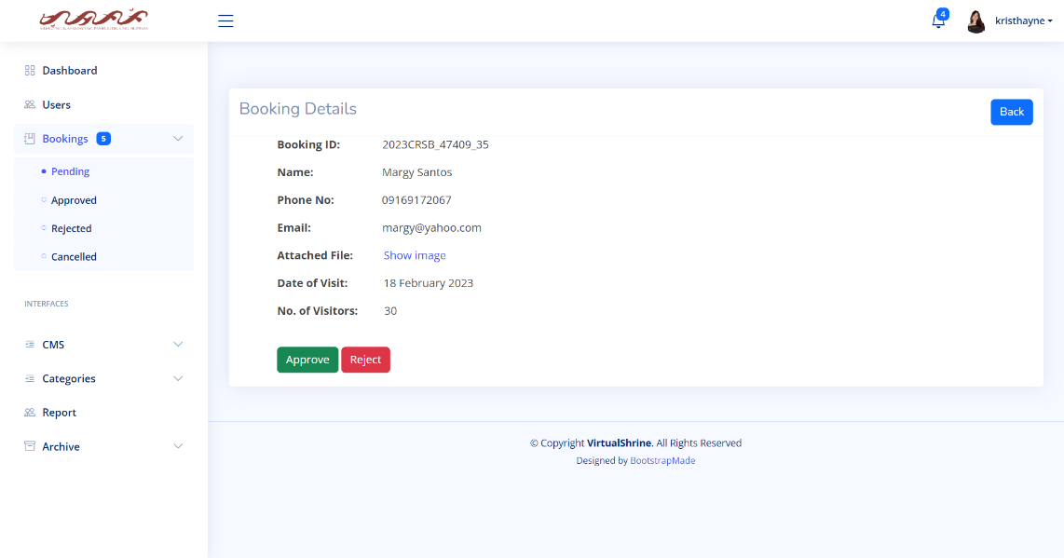 Figure 39 shows the Booking Details page, containing all the information that the visitor submitted during the booking process.

**Figure 39. Booking Details**

This page shows visitors' booking ID, name, contact info, date of visit and number of visitors. Admins can view attached ID to confirm identity and easily approve or reject booking.

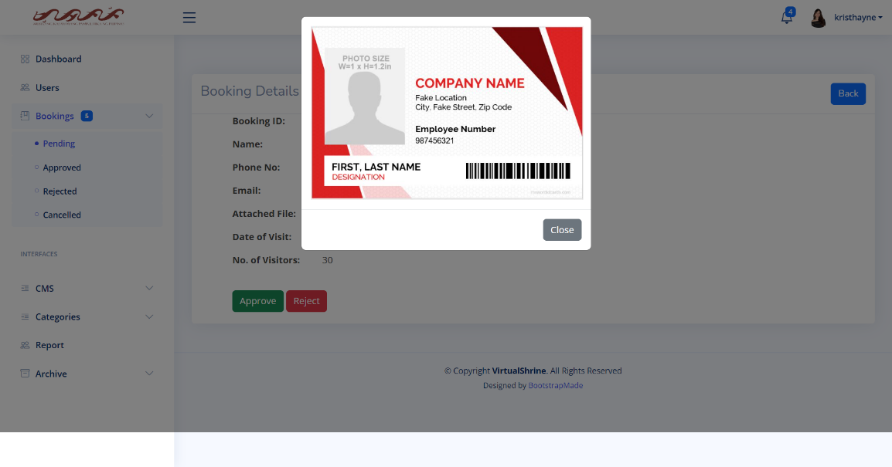Figure 40 shows the Attached File preview that the admin can utilize to verify the identity of a visitor.

**Figure 40. Attached File preview**

The preview reveals the visitor's ID, which the admin can use to confirm that the booking details are accurate. Additionally, the Attached File preview allows the admin to quickly access the necessary information to process the booking.

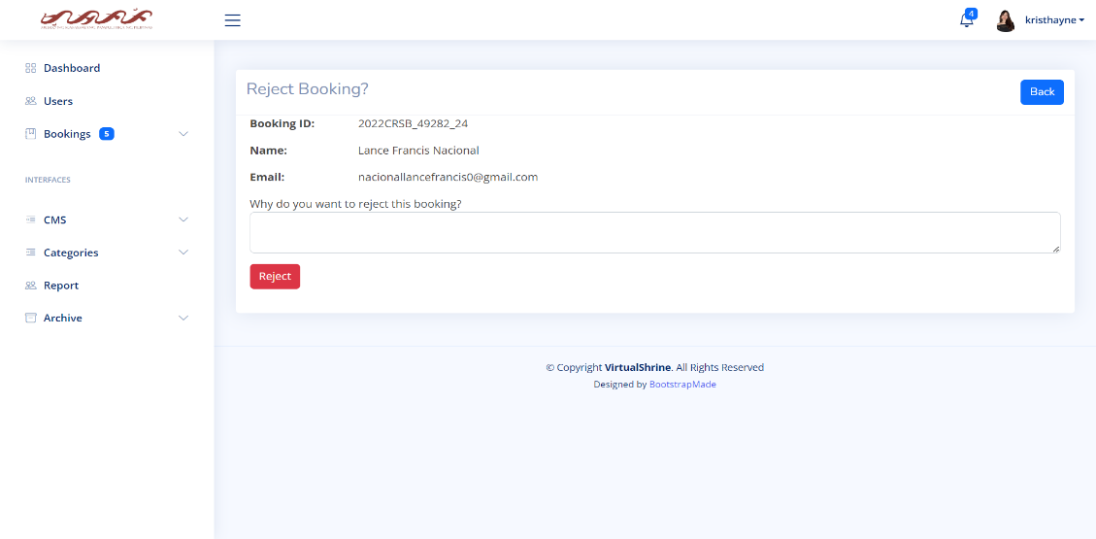Figure 41 displays the Reject Booking page, which is a feature that allows museum administrators to reject a booking made by a visitor.

**Figure 41. Reject Booking page**

The page displays primary visitor and a text box for the admin to input the reason for rejection. Clicking the "Reject" button finalizes the process. This feature is key to the museum's booking system, allowing administrators to respond quickly and efficiently while ensuring capacity is not exceeded. An email notification also provides an easy way for visitors to understand why their booking request was denied.

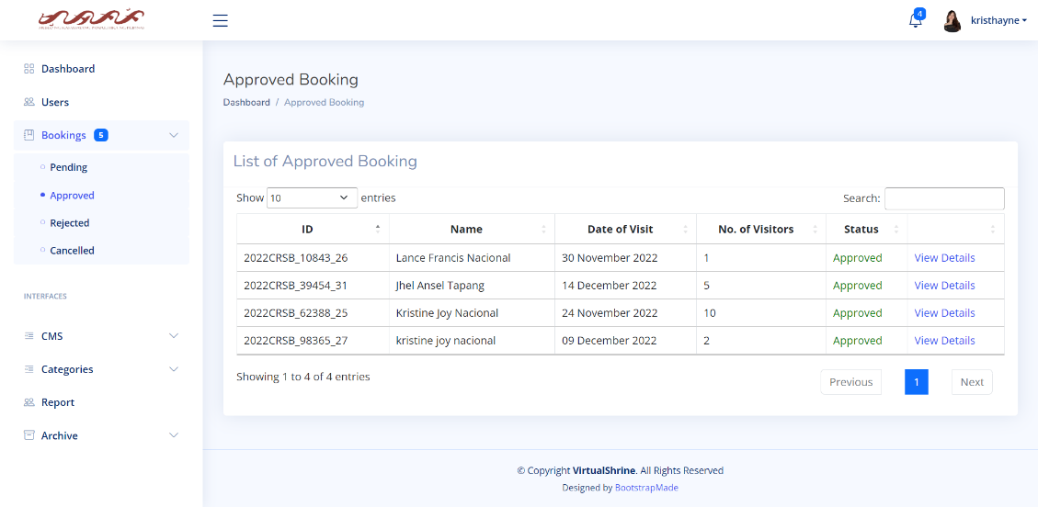Figure 42 displays the Approved Booking Panel, which allows admins to view and manage a list of all the bookings that have already been approved.

**Figure 42. Approved Booking Panel**

This feature is designed to help admins quickly and easily confirm visitors' bookings once they have arrived at the museum. The Approved Bookings Panel also allows admins to access useful information about the bookings, such as the number of people, the date of the booking, and the contact information of the visitor.

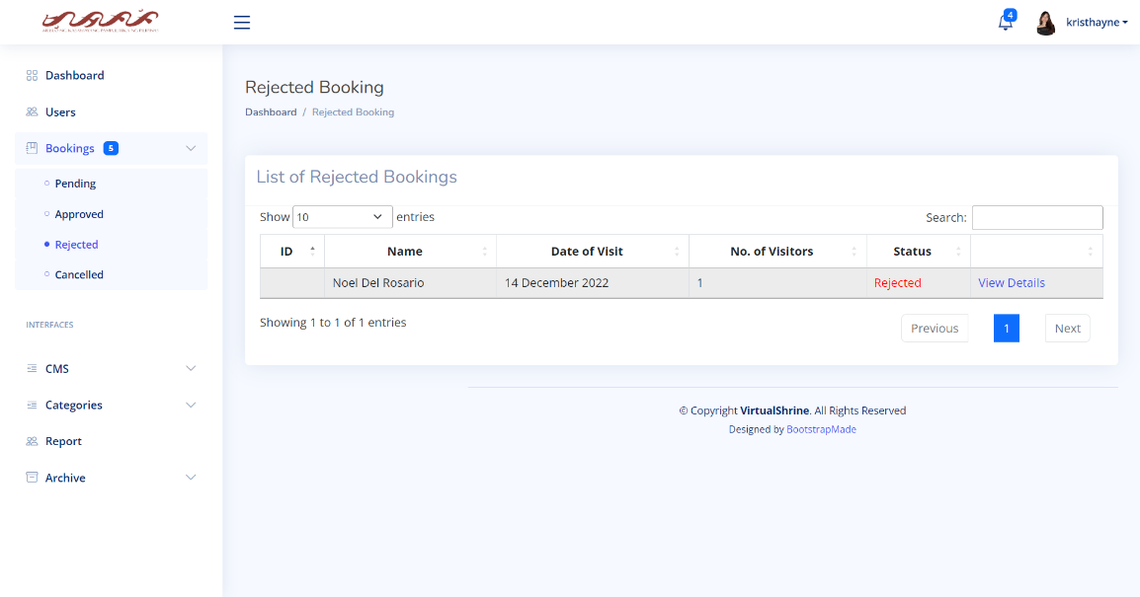Figure 43 displays the Rejected Booking panel, which allows admins to view and manage a list of all the bookings that have already been rejected.

**Figure 43. Rejected Booking Panel**

This panel provides the user with an overview of all the rejected bookings, including details such as the booking ID, and name of visitor. This panel is an essential tool for admins to ensure all bookings are handled efficiently.

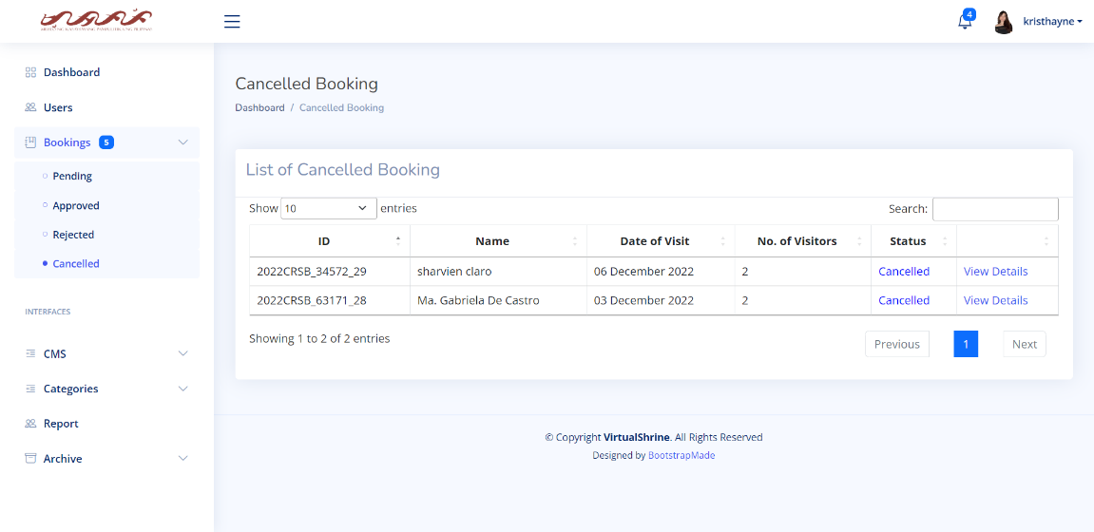Figure 44 displays the Cancelled Booking panel, which allows admins to view the bookings that have been cancelled by visitors.

**Figure 44. Cancelled Booking Panel**

This panel can help analyze visitor cancellation trends and make necessary changes to improve the booking experience.

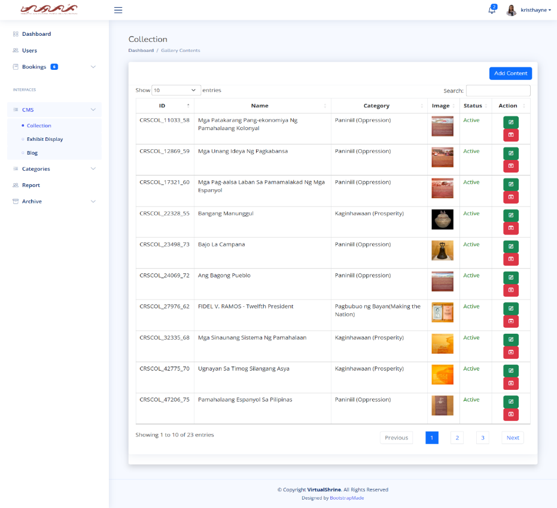Figure 45 illustrates the CMS - Collection panel of the website, providing admins with an overview of all the components in the website gallery.

**Figure 45. CMS - Collection Panel**

This panel includes a variety of gallery contents, allowing users to easily browse and find the items they are looking for. Additionally, this panel also allows admins to add new contents, and edit existing contents. Only the super admin can archive contents. Additionally, this panel also includes an advanced search option, allowing admins to quickly search for items. Furthermore, the panel also includes sorting and filtering tools which help users organize the contents and make it easier to navigate.

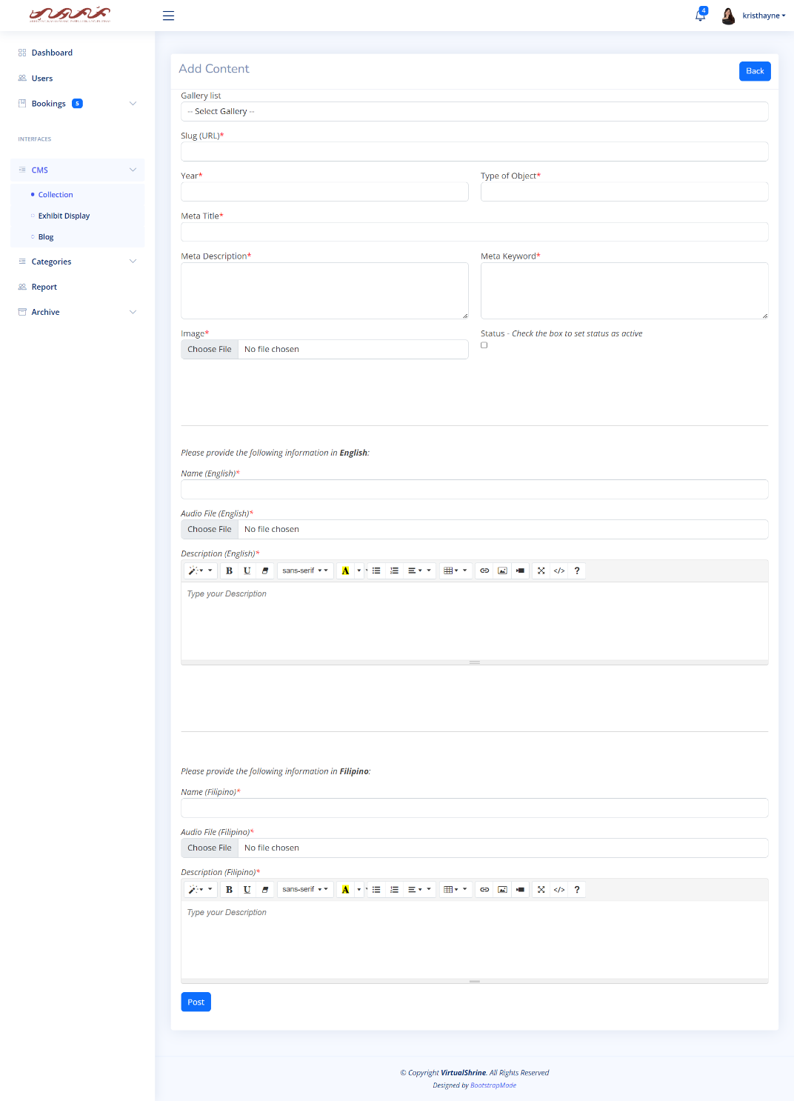 Figure 46 displays the Add Content form, this form will allow admins to upload new contents to the VirtualShrine website.

**Figure 46. Add Content Form**

This form provides admins with a variety of options for uploading content, such as text, images, and audio. Additionally, admins can enter title, description, and tags for the content. This form also allows admins to select the content type and visibility, as well as assign the content to a particular category. Once the necessary information is entered, admins can click the ‘Post’ button to upload the content to the website.

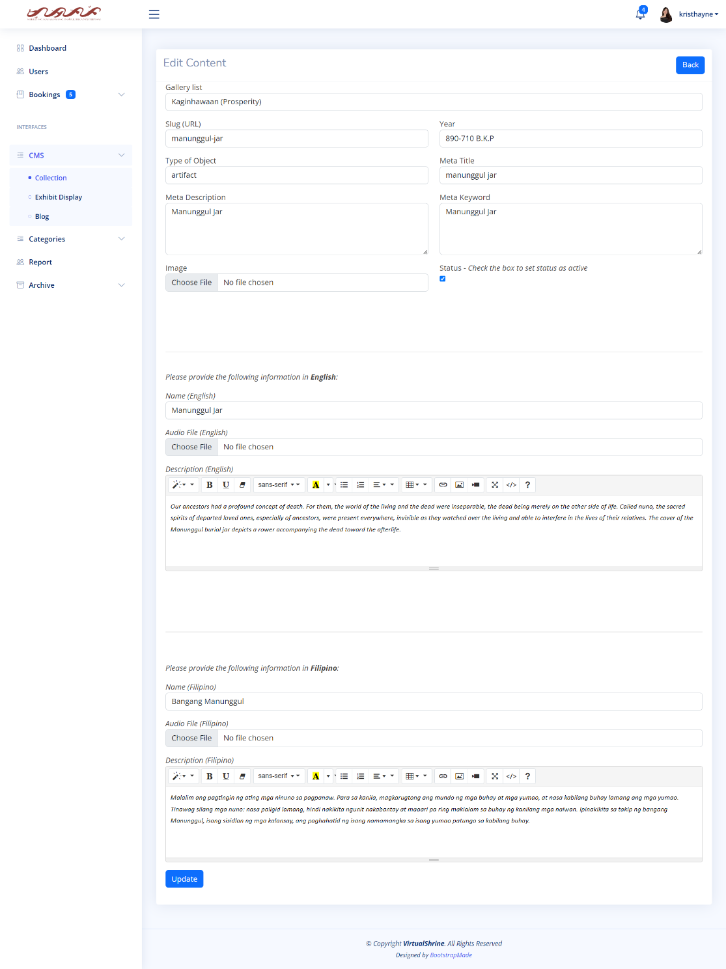Figure 47 displays the Edit Content form which allows the admins to make changes to existing content in the VirtualShrine website.

**Figure 47. Edit Content form**

This form provides the user with a range of options including the ability to modify existing content by deleting, adding, or editing text, images, and audio files. Other options such as setting the content's visibility can also be found in the Edit Content form. This form is an essential tool for the admins in managing and maintaining content on the VirtualShrine website.

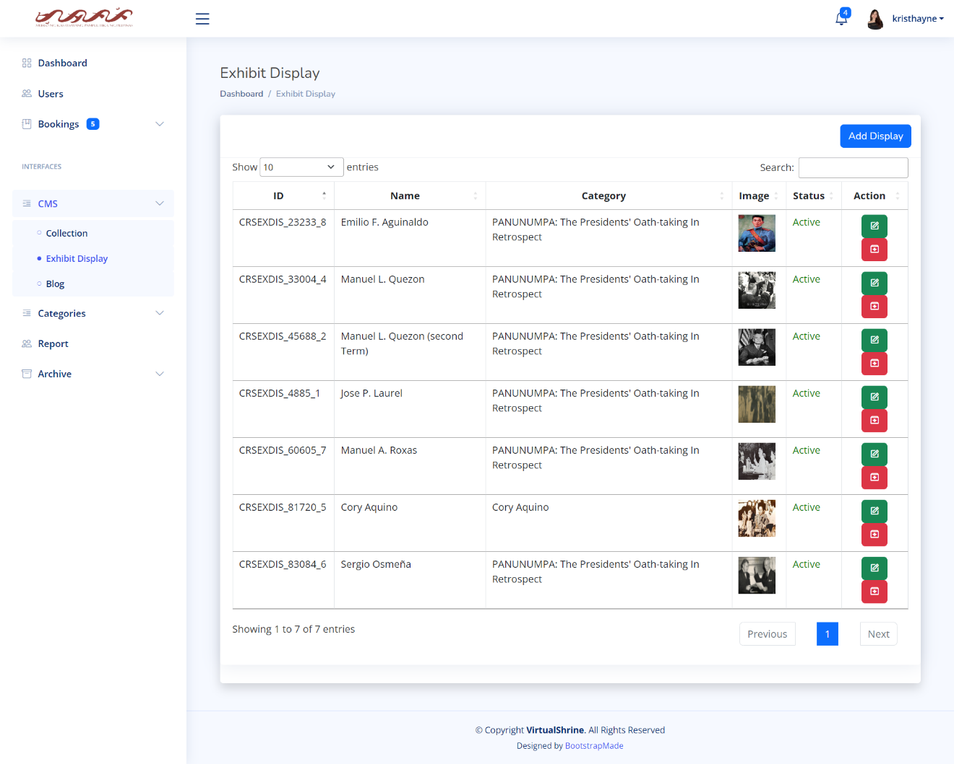 Figure 48 displays the CMS - Exhibit Display panel, which is a feature under the content management system (CMS) menu that allows administrators to view and manage all their Exhibit Displays in the VirtualShrine website.

**Figure 48. CMS - Exhibit Display panel**

This panel provides an overview of all of the Exhibit Displays created, including their titles, descriptions, and dates of creation. Additionally, admins can also see which displays are currently active or inactive, as well as any other relevant data associated with the displays. This feature of the CMS is useful for quickly and easily managing and monitoring the status of all displays in the exhibit.

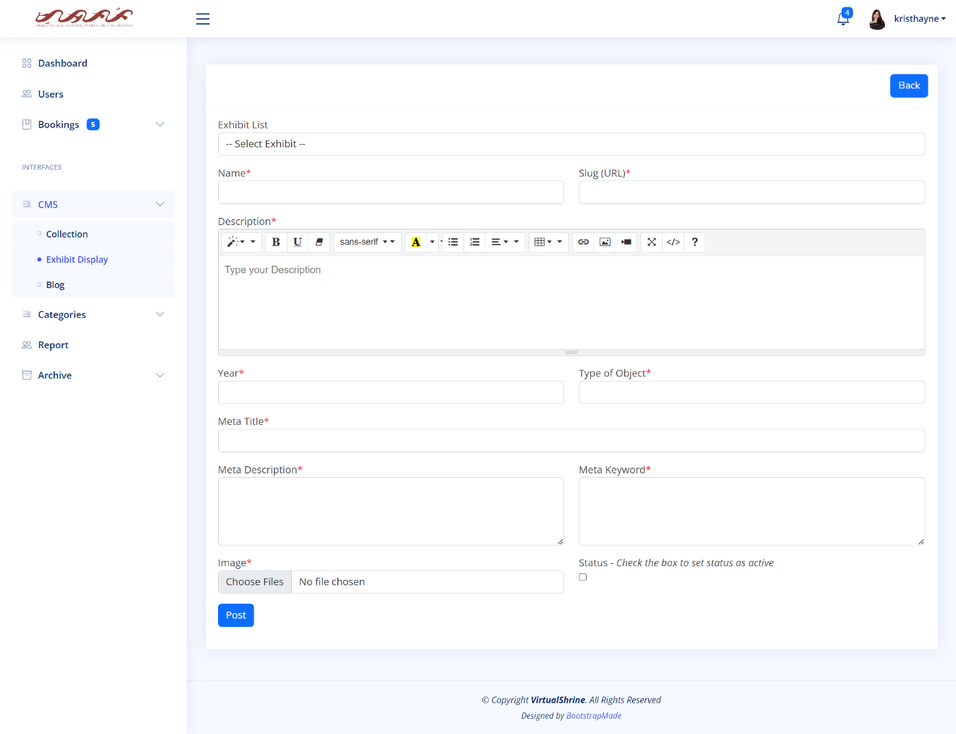Figure 49 displays the Add Exhibit Display form, which enables admins to create new exhibit displays for the VirtualShrine website.

**Figure 49. Add Exhibit Display form**

This form allows admins to easily create and manage new exhibit displays. Through the form, admins can select an active exhibit from the dropdown list to assign the display to a specific exhibit, and provide a Name, Description, and Image for the display. Once all the details are filled in, admins can click the 'Post' button to save the new exhibit display. This will add it to the chosen existing list of active exhibits, providing visitors with more information and visuals about the display.

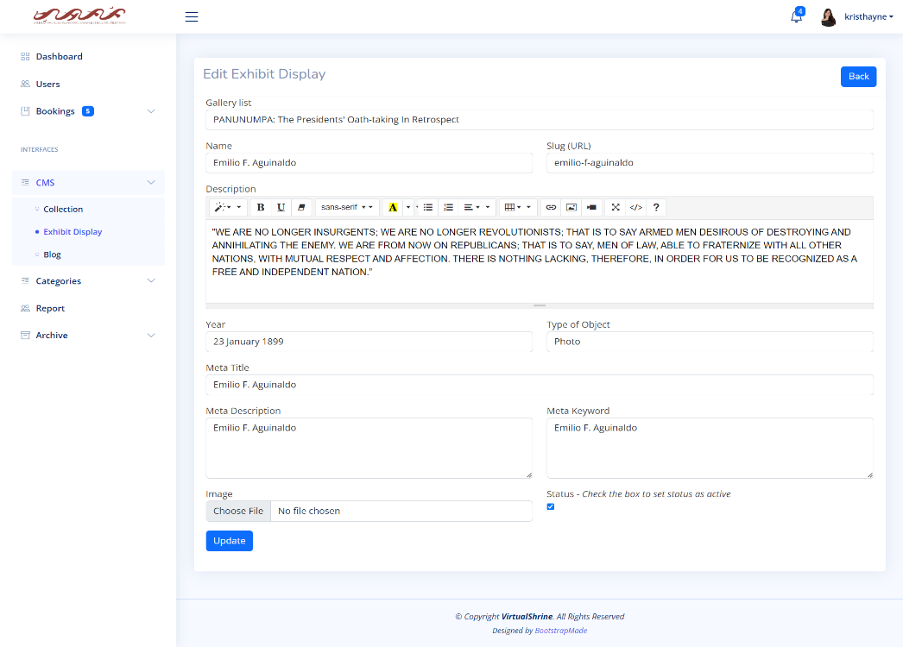Figure 50 displays the Edit Exhibit Display form which allows the admins to modify the existing Exhibit Display.

**Figure 50. Edit Exhibit Display**

Using this form, admins can make changes to the existing display, such as changing the name, description, and images associated with the Exhibit. Administrators also can change where the display is in the exhibit list, as well as change the status visibility of the display. With this form, admins have full control over the Exhibit Display, allowing them to customize it to meet their specific needs.

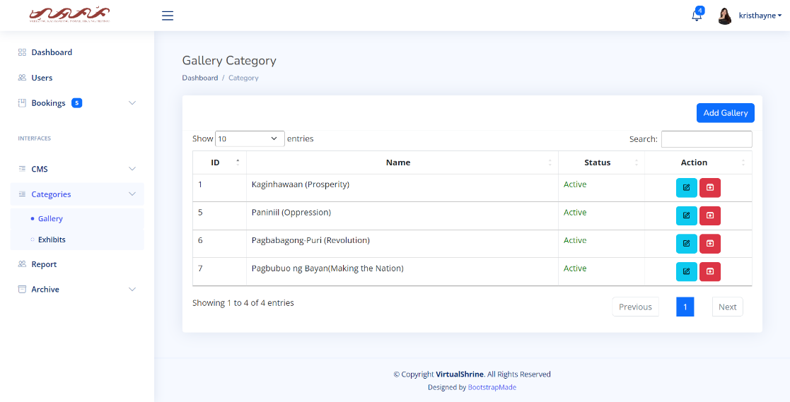 Figure 51 displays the Gallery Category panel, which enables administrators to view and manage the various Gallery Categories.

**Figure 51. Gallery Category**

This panel provides the ability to add, edit, and archive categories, as well as view a list of all categories and their associated images. Admins can also select images to assign to each category, allowing visitors to easily browse the galleries by category.

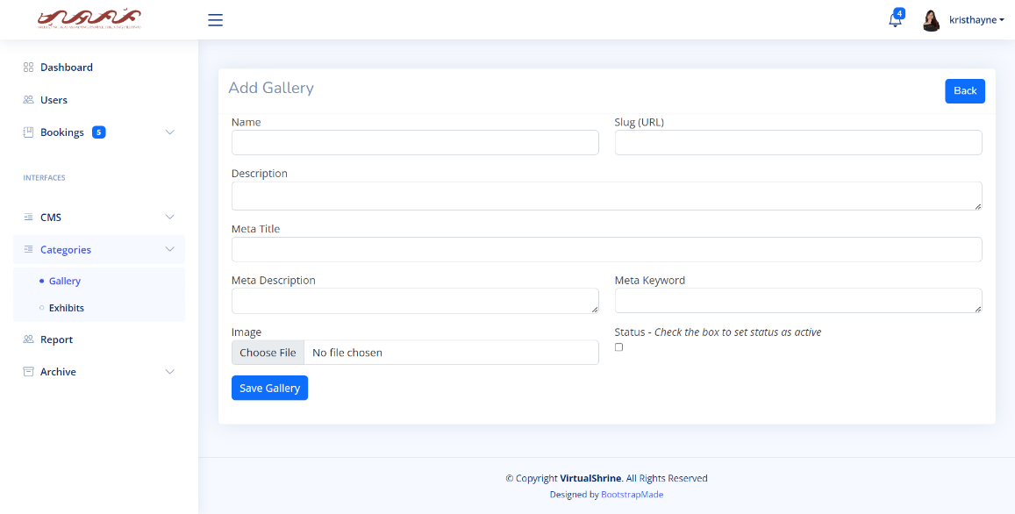Figure 52 displays the Add Gallery Category form which allows the admin to add a new Gallery Category into the VirtualShrine website.

**Figure 52. Add Gallery Category**

This form contains fields for the category name, and description. After entering the required information, the admin can click the Save Gallery button to add the new category. The newly added category will then be visible on the Gallery page (Figure 23), allowing users to view the category and its contents.

Figure 53 displays the Edit Gallery Category form, which allows the admins to edit an existing Gallery Category.

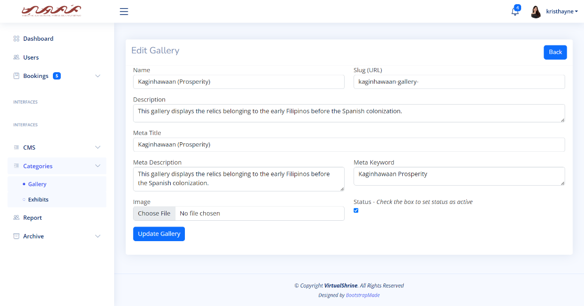



**Figure 53. Edit Gallery Category form**

Admins can use this form to change category name, description, active status, and change or remove images. This form is essential for organizing and managing gallery categories.

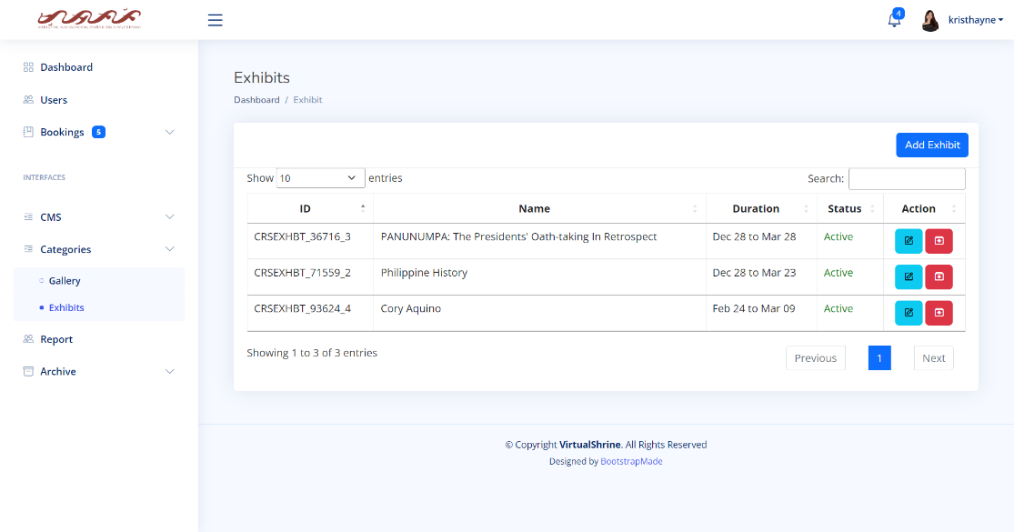Figure 54 displays the Exhibits panel, which enables administrators to view and manage the various Exhibits.

**Figure 54. Exhibits Panel**

This panel provides a variety of options, such as creating a new Exhibit, editing an existing Exhibit, and archiving an Exhibit. Additionally, the Exhibits panel allows administrators to view a list of all Exhibits, view the details of each Exhibit, and enable or disable a particular Exhibit.

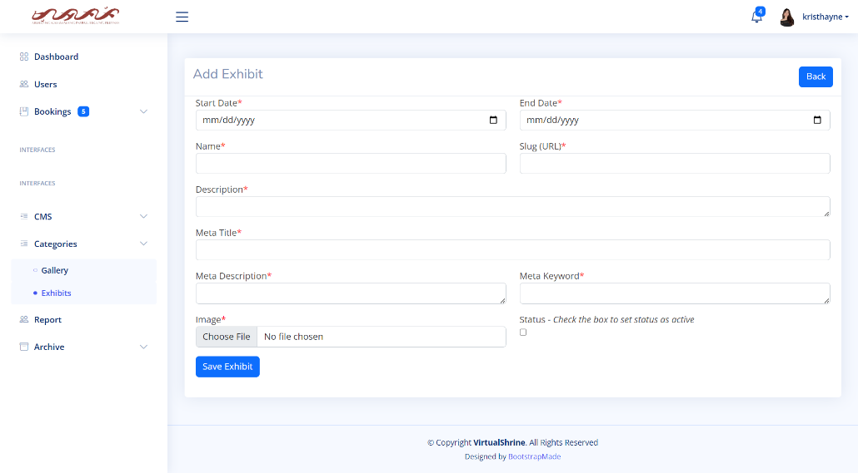 Figure 55 displays the Add Exhibit form, which allows the admins to create a new exhibit for the VirtualShrine Website.

**Figure 55. Add Exhibit form**

This form is used to input all the information concerning the new exhibit, including the exhibit’s start and end date, name, and description, along with the associated images. Once all the required details have been filled in and the form is submitted, the new exhibit will be added to the system and can be viewed by all users.

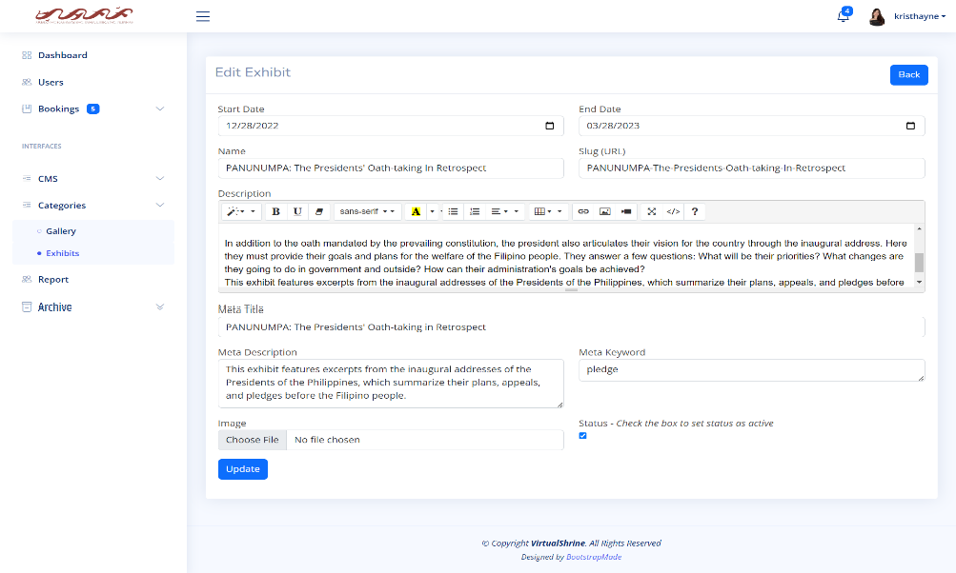Figure 56 displays the Edit Exhibit form, which allows admins to modify existing exhibits.

**Figure 56. Edit Exhibit Form**

This form is used to edit existing exhibit information such as the start and end date, exhibit name and description, and associated images. Additionally, admins can add new images, delete existing ones, or rearrange the order of the images. Once all the necessary changes have been made and the form is submitted, the exhibit will be updated within the system and the changes will be visible to all users.

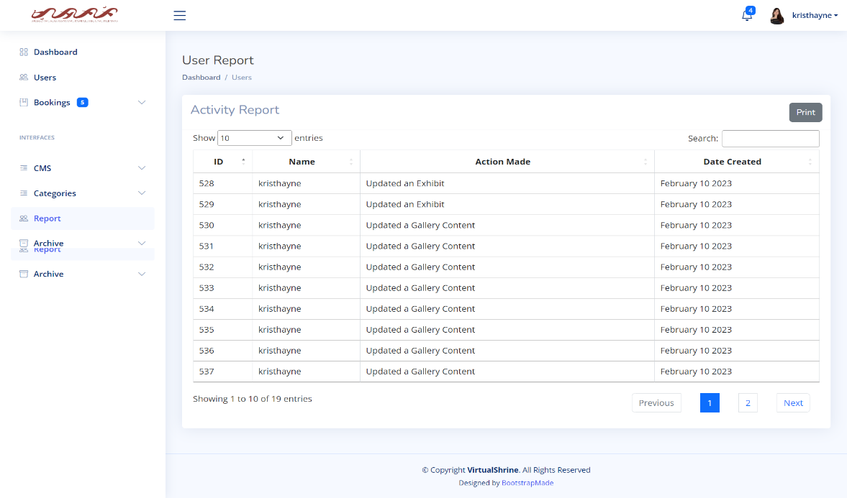Figure 57 displays the User Report panel, which the super admin can use to track the activity of all assistant admins within their organization.

**Figure 57. User Report panel**

This panel gives the super admin a comprehensive view of assistant admin activities, allowing for easy search and viewing. They can view activities such as modifying website content, approving or declining museum visitor bookings, and changing assistant admin accounts.

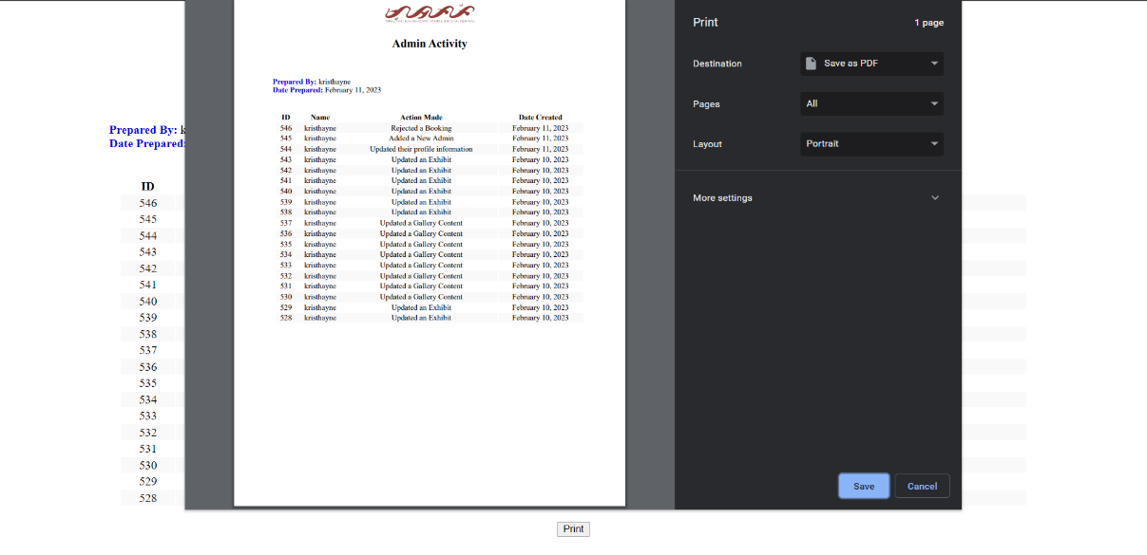Figure 58 displays the Print User Report.

**Figure 58. Print User Report**

The super admin can export the report results as a PDF, providing flexibility and convenience when needing to view the report results.